**Program note by Chris Darwin: use freely for non-commercial purposes**

**Felix Mendelssohn (1809-1847) Piano Trio No 1 in D minor Op 49 (1839)**

*Molto allegro ed agitato*

*Andante con moto tranquillo*

*Scherzo: Leggiero e vivace*

*Finale*

By 1839, the 30-year-old Mendelssohn was established. He had been in Leipzig conducting the Gewandhaus Orchestra for four years, and had been married for two. His work load was daunting: conducting and also frequently performing as pianist in 20 Gewandhaus orchestral concerts a year, together with chamber concerts, charity concerts, and *ad hoc* concerts for visiting virtuosi. The Gewandhaus concerts were an eclectic mix of the classics (mainly Beethoven and Mozart) and the contemporary (including Mendelssohn's own works). One notable 1839 concert featured the world premiere of Schubert's 'Great' C-major symphony which Robert Schumann had recently unearthed in Vienna. As well as orchestral works the concerts often included acts from operas or chamber music perhaps with Mendelssohn himself on piano.

In his teens Mendelssohn had explored various chamber music forms, most notably the remarkable String Octet of 1825 and his first two published String Quartets, but also three less-frequently played Piano Quartets which preceded the Octet. In 1837 he had returned to composing chamber music after a gap of almost 10 years, working on a set of three String Quartets while on his honeymoon. Tonight's D minor Piano Trio followed soon after in 1839. Schumann loved it: *‘This is the master trio of our age, as were the B flat and D major trios of Beethoven and the E flat trio of Schubert in their times. It is an exceedingly fine composition which will gladden our grandchildren and great-grandchildren for many years to come.’* Yet it had not been without its problems. AsRobert Philip points out:

'After Mendelssohn had finished it, he showed it to the composer Ferdinand Hiller, who was staying with him in Leipzig. Hiller was very impressed, but had *‘one small misgiving. Certain pianoforte passages in it, constructed on broken chords, seemed to me – to speak candidly – somewhat old-fashioned.’* Hiller was a long-time friend of Liszt and Chopin, andwas *‘thoroughly accustomed to the richness of passages which marked the new pianoforte school’*. The result of Hiller’s suggestions was that Mendelssohn rewrote the entire pianopart, making it less conventional in style – and, no doubt, much more difficult to play.'

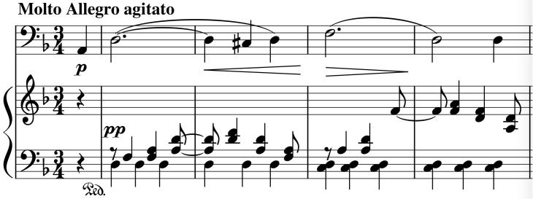

An example of this 'new school' writing may

perhaps be in the very opening (*illustrated*),

where Mendelssohn rapidly alternates the left

and right hands of the piano's accompaniment

to augment the sense of agitation, pushing

forward the gloriously expansive cello

melody.

The slow movement has a tender beauty, a 'Song without words', with the strings echoing the piano. The tenderness becomes more impassioned after the piano

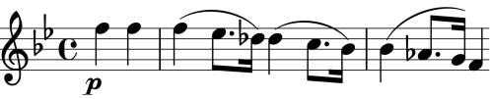

recalls a descending idea that the violin had used as a counter-melody in the first movement (*illustrated*).

The 'light and lively' *Scherzo* is trademark Mendelssohn recalling the *Scherzo* of the precocious Octet. Masterfully written, it is even now a challenge to play at the blistering marked tempo of one bar a second. The last movement can't compete for sheer tempo, but uses more traditional means:

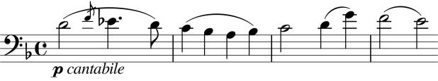

contrapuntal ingenuity driven by a fiendishly complex piano part, and then the cello bursting forth with the most gloriously optimistic theme of the whole wonderful work (*illustrated*).