Programme Note by Chris Darwin: please use freely for non-commercial purposes

**Felix Mendelssohn (1809-1847) String Quartet No.2 in A Minor, Op 13 (1827)**

*Adagio - Allegro vivace*

*Adagio non lento*

*Intermezzo: Allegretto con moto - Allegro di molto Presto - Adagio non lent*

Two people unwittingly contributed to the composition of Mendelssohn's 1827 A minor quartet: Beethoven, who had recently died, and Betty Pistor, a 19-year old neighbour and friend of Mendelssohn's younger sister Rebekah. Earlier in the year Mendelssohn and Betty had sung in the same choir; he fell in love with her, wrote her a love-poem (under the pseudonym of H. Voss)

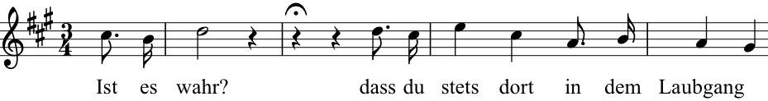

entitled *Frage* (*Question. 'Is it true that you are always there …?'*), which

he turned into a short song. The theme of the song became the heart of the quartet. Mendelssohn's infatuation with Betty persisted, although she regarded him simply as an admirable and talented friend, and she also appears in various coded guises the following year in his next quartet, the Op 12 in Eb. Sadly, the dedicatee's initials had to be changed from BP to BR when she married a law professor. Despite, or perhaps because of, her lack of interest in the young composer, she inspired two wonderful quartets.

Beethoven's contribution to Op 13 was less romantic. His late quartets had recently been published, but he was out of fashion; few recognised their value. Mendelssohn's own father agreed with Spohr's view that they were *'indecipherable, uncorrected horrors'*. But the 18 year-old Felix studied them closely and incorporated many of their compositional techniques and even motifs into his Op 13. It was a brave, liberating choice to take the late quartets as his model rather than the Mozartian early or heroic middle ones. That he was successful in capturing something of Beethoven is clear from an anecdote that Roger Parker recounts of Mendelssohn attending the Op 13 quartet's Parisian premiere: 'During the last movement, the person sitting next to [Mendelssohn] tugged on his coat and said: "*It's like that in one of his symphonies*". Mendelssohn was confused and asked for clarification. His companion explained: "*Beethoven, the composer of this quartet*".'

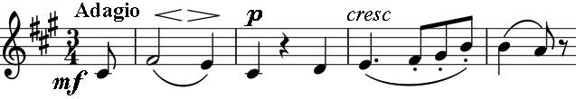

The A major *Adagio* introduction to the first movement is close to a simple inversion of the *Adagio ma non troppo* A minor start of Beethoven's Op 130. Mendelssohn then again follows Beethoven with rapid running semiquavers at the start of the main *Allegro vivace*. Mendelssohn's genius for melody

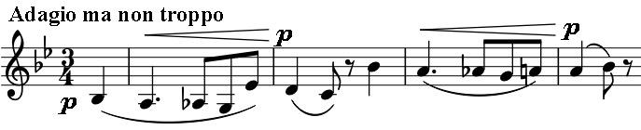

blossoms in the glorious theme of the slow movement, which after a tender fugal passage gives way to a sprightlier episode reminiscent of the interruptions to the *Heiliger Dankgesang* slow movement of Beethoven's Op 132 A-minor quartet. A more purely Mendelssohn *Intermezzo* follows, with another

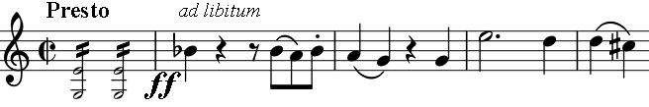

early example of his Midsummer Night's Dream style in the *Allegro* section. But Beethoven returns in the last movement: the first violin's *ad libitum* recalls the Baritone's

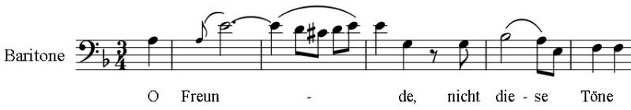

recitative near the beginning of the last

movement of the Ninth Symphony. The

last section of the movement returns to the introductory *Adagio*, filling it out into the “Ist es wahr?” music which has always been behind this extraordinary quartet.