Programme Note by Chris Darwin: please use freely for non-commercial purposes

**Felix Mendelssohn (1809-1847) String Quartet Op. 44 No.2 in E minor (1837)**

*Allegro assai Appassionato*

*Scherzo – Allegro di molto*

*Andante*

*Presto agitato*

Felix Mendelssohn was born into an intellectual and affluent household: his grandfather Moses was the pre-eminent Jewish philosopher of the Enlightenment, and both his father and mother’s family were bankers. Felix and his sister Fanny were outstandingly precocious and were driven hard by their parents – their day started at 5 am at the latest. In 1818 the 9-year old Felix publicly performed a Dussek piano concerto from memory, and his first datable composition was performed in Berlin the same year. His copious early compositions outshone even those of Mozart. When Mendelssohn was 12 he played for Goethe who had also heard the young Mozart. Goethe was impressed: *“...what [Mendelssohn] already accomplishes bears the same relation to the Mozart of that time that the cultivated talk of a grown-up person bears to the prattle of a child.”* At the age of 16 he produced his first undoubted masterpiece, his String Octet Op 20, incidentally at the same time as a metrically accurate German translation of a comedy by Terence which was published by his tutor the following year!

Mendelssohn’s string quartets fall into four groups: an early (even for Mendelssohn) quartet from 1823; the Op 12 & 13 quartets written in 1829 & 1827 respectively; the three Op 44 quartets including today’s from 1837-8, and finally the Op 80 quartet, a personal outpouring of grief written in 1847 in response to Fanny’s unexpected death, and only a few months before his own. The A minor Op 13 quartet appeared shortly after Beethoven’s late quartets were published; Mendelssohn studied them closely and incorporated many compositional techniques especially from Op 132 & 135 into his Op 13, giving us an interesting link between “classical” and “romantic” quartet writing.

Mendelssohn started work on today’s E-minor quartet in the spring of 1837 while on honeymoon, with his young French bride Cécile (10 years his junior and *“fresh, bright and even-tempered”* in Fanny’s view); he finished it in Frankfurt on 18 June.That October it was given its first performance by a quartet led by Ferdinand David who coincidentally had been born a year after Mendelssohn in the same house in Hamburg.

The first movement opens with syncopated crotchets pushing forward, and an

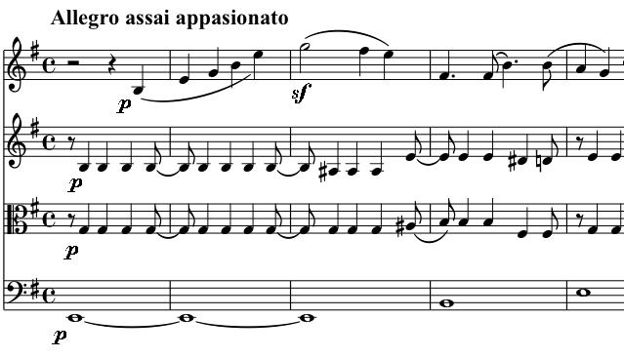

optimistically rising theme on the first

violin. Soon an even more energetic

figure appears – unison semiquavers in

all four instruments, which are

subsequently fragmented and tossed

between the players. Some repose and

reflection comes with a tender (more

feminine?) theme from the first violin:

Mendelssohn develops and combines these contrasting ideas with apparently effortless fluency, ending *tranquillo* in

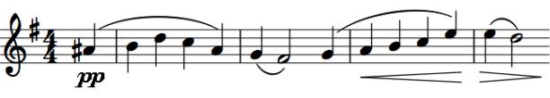

the major with the two main themes happily reconciled.

The E-major Scherzo is heir to the light, staccato, tripping scherzo writing of his Octet and Midsummer Night’s Dream overture. The G-major Andante also moves onward (Mendelssohn warns the players *“This piece must never be allowed to drag”*) with two bars of fluid, pulsing semiquavers from the second violin stretching and opening the windows to allow in the first violin’s beautiful song.

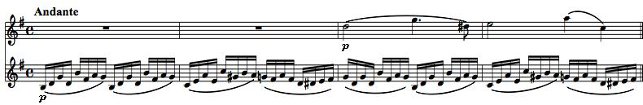

It *was* written on his honeymoon after all!

The last movement opens with a restless figure in the minor key; relentlessly energetic quavers carry us along until we reach this expansive theme in the major: The quavers are persuaded to go into the

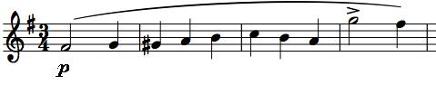

major for a while too, but return to the minor and power on tirelessly to a triumphant conclusion.