Program Notes by Chris Darwin. Please use freely for non-commercial purposes.

**Witold Lutos!awski (1913-1994) *Subito* for violin and piano (1992)**

This short (4-minute) piece was almost the last that Lutos!awski completed. His life was moulded by two world wars. His father, a cultured Polish estate owner, was executed in Moscow's Lublyanka by the Bolsheviks in 1918. Witold himself was captured by German forces in 1939, but escaped after only a week. He spent the rest of the war in Warsaw earning an illicit living playing in cabarets and giving concerts, some in a piano duo with fellow composer Andrzej Panufnik. During the subsequent Stalin era Lutos!awski met its constraints by writing music for which there was a social need, "functional" music, into which he incorporated elements of folk music. His popular *Concerto for Orchestra (1954)* dates from this period. Post Stalin, he developed a personal twelve-tone style, beginning with *Funeral Music* (1958) composed in memory of Bartók. A third phase was inspired by hearing a work by John Cage; Lutos!awski's compositions began to incorporate elements of random choice by the players. From the 1970s on, he became increasingly recognised internationally, with many prizes and commissions from leading performers.

*Subito* was commissioned by Joseph Gingold for the 1994 International Violin Competition in Indianapolis. Lutos!awski had learned the violin as a child and in 1984 had been inspired to compose for the violin by the playing of Anne-Sophie Mutter. He enjoyed the "functional" challenge of a piece that showed off the competitors' virtuosity. *Subito's* title has been associated with its 'out of the blue' start

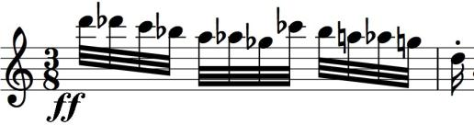

(illustrated) and abrupt mood changes. The mood changes may also reflect his own emotional turmoil: he had been recently diagnosed with the

cancer that prevented him from completing a violin concerto for Mutter.

The opening few bars of *Subito* form a refrain that alternates four times with varied episodes. With each repeat the refrain gets shorter and the episodes more complex. A long high trill marks the climax and the piece ends with another version of the refrain.