Programme Note by Chris Darwin: please use freely for non-commercial

**Franz Liszt (1811-1886)**

*Nuages gris (1881)*

*Jeux d’eau à la Villa d’Este (1877)*

*Variations on Bach’s Cantata “Weinen, klagen, sorgen, zagen” (1862)*

*(“Weeping, lamenting, worrying, fearing”)*

I will deal with these three pieces chronologically, in reverse order of performance.

In 1714, Bach was promoted to Konzertmeister in the Schlosskirche in Weimar, a post which involved composing a monthly cantata. *“Weinen, Klagen, Sorgen, Zagen”* is the second cantata in this series, composed for the third Sunday after Easter. Its chromatic-ally descending chorus

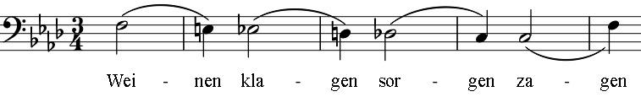

provides the material for Liszt, who was himself Kapellmeister in Weimar

from 1842 to 1861. Liszt's extremely varied variations would have provided a showcase for his astounding technique in performance. The piece ends with a setting of the Bach chorale *“Was Gott tut, das ist wohlgetan”* (What God does, is well done).

The period around the composing of these variations in 1862 was a very testing one for Liszt. He failed, at the last minute, to marry Princess Carolyne zu Sayne-Wittgenstein, who had lived with him during his time in Weimar; her Russian husband and the Tsar had succeeded in persuading the Vatican to quash its reluctant annulment of Carolyne's existing marriage. In addition, Liszt lost two of his chidren: in 1859 his son Daniel, and in September 1862 his daughter Blondine. His younger daughter Cosima married his talented pupil Hans von Bülow, but in 1863 began an overt affair with Wagner. In June 1863 Liszt retreated to a monastery in Rome.

By 1868, the Abbé Liszt had become something of a tourist attraction at the Santa Francesca Romana monastery, a status that was not conducive to composing. He therefore welcomed the invitation of Cardinal Hohenlohe to stay at the Villa d'Este at Tivoli. A small wing of the villa became his residence of choice, and composition flourished there. The villa dates back to the 16th century and is one of the marvels of Italy with its waterfalls and fountains, powered by a diverted river, being especially beautiful.

***Les jeux d'eaux à la Villa d'Este****,* written in 1877, forms part of the "*Third Year*" of a set of three “*Years of Pilgrimage*” that he had started during his concert-touring years. Although previously noted for his inexhaustible energy, by 1877 Liszt was bordering on a depressive breakdown; he would sit for hours just staring at the fountains of the villa. Reflecting this mood, the *jeux d'eaux* is preceded in the set by two elegiac threnodies on the cypresses of Villa d'Este. By contrast, the *jeux d'eaux* itself is a masterpiece of musical impressionism that would remained unrivalled until Ravel's composition of the same name thirty years later.

***Nuages gris*** dates from four years later and is an example of the strange, remote language that appeared abruptly in Liszt's old age, apparently unconnected with his earlier exuberant compositions. The bleak mood of this piece may

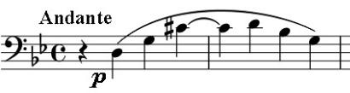

well have also been influenced by a severe fall that he had

suffered a few weeks earlier in Weimar. The opening

(*illustrated*) could not be more spare. Alan Walker in the New

Grove: *“with its gently grinding dissonances, its free approach to tonality, and its abandoned ending, it has a claim to be a gateway to modern music.”*