Vision quartet NYS 1.3.2019

**Franz Schubert (1797-1828) Quartettsatz in C minor, D.703 (1820)**

*Allegro assai*

At the age of eight, Schubert started to learn the violin from his father; six years later he was composing for the family string quartet: brothers Ignaz and Ferdinand on violin, Franz on viola and his father on cello. However, the eleven or so quartets that Schubert wrote between the ages of 14 and 20 are now, like Mozart's early quartets, rarely played. The exuberant “Trout” piano quintet of 1819 and this *Quartettsatz, a* surviving first movement of a planned C minor quartet, written in 1820, set the scene for the great chamber works of his later years: in 1824 the Octet, the “Rosamunde” and “Death and the Maiden” quartets; in 1826 the G major quartet; in 1827 his two piano trios; and in his last year,1828, the incomparable C major two-cello quintet.

It is not clear why Schubert failed to continue with the “*Quartetsatz*” quartet beyond its first movement and a sketch of 40 odd bars for an *Andante*. It may be that he was unable to match the power of the first movement to make a hoped-for great leap forward in quartet writing. The movement opens

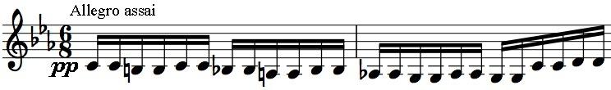

with threatening, semitonal creepings (*illustrated*). “*The phrase itself has a dramatic*

*intensity which is new in Schubert's chamber music, an intensity which is all the more powerful because it begins quietly*” (Jack Westrup). The tension is relaxed by the joyfully open *dolce* second subject in *Ab* major

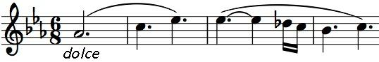

(*illustrated*); it encourages the transformation of the opening phrase into more nostalgic versions of itself, before its final emphatic return.

**Programme note by Chris Darwin. Use freely for non-commercial purposes**

**György Ligeti (1923-2006) String Quartet No. 1 ("Métamorphoses nocturnes")**

**(1953/4)**

A single 20-minute movement is divided into 17 contrasting sections:

|  |  |  |  |
| --- | --- | --- | --- |
| *1.* | *Allegro grazioso* | *10.* | *Subito: molto sostenuto* |
| *2.* | *Vivace, capriccioso* | *11.* | *Allegretto, un poco gioviale* |
| *3.* | *A tempo* | *12.* | *Allargando. Poco più mosso* |
| *4.* | *Adagio, mesto* | *13.* | *Subito allegro con moto, string. poco* |
| *5.* | *Presto – Prestissimo* |  | *a poco sin al prestissimo* |
| *6.* | *Molto sostenuto – Andante tranquillo* | *14.* | *Prestissimo* |
| *7.* | *Più mosso* | *15.* | *Allegro comodo, gioviale* |
| *8.* | *Tempo di Valse, moderato, con* | *16.* | *Sostenuto, accelerando – Ad libitum,* |
|  | *eleganza, un poco capriccioso* |  | *senza misura* |
| *9.* | *Subito prestissimo* | *17.* | *Lento* |

The young Ligeti suffered under two totalitarian regimes: the Nazis and the Communists. Born in Transylvania to a Hungarian Jewish family, his brother and both parents were sent to concentration camps – only he and his mother survived. Between 1949 and 1953, when Ligeti strove to develop an individual style of composition, Hungary was a country in

the grip of Stalinist repression. The young Ligeti could find no public outlet for his rebellious creativity. The state demanded endless helpings of folk-based choral music, so more interesting compositions (such as his *Six Bagatelles* for wind quintet which the Magnard Ensemble played last season) were kept concealed. Stalin's death slackened the state's grip, encouraging Ligeti in the exuberant, fantastic invention of his first string quartet, although the work was not performed until 1958 when Ligeti had fled Budapest for Vienna, subsequently taking Austrian citizenship. Bartók was a major influence, but in the young Ligeti he appears with reduced angst – as if the young Bartók's adored girl-friend Stefi Geyer had rewarded his marriage proposal with a "Yes!" and a big ice-cream rather than turning him down flat.

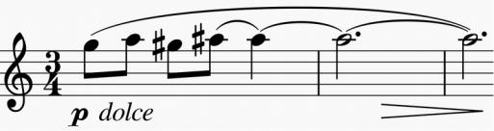

Ligeti's first quartet consists of a series of variations – metamorphoses – of a chromatic figure (*illustrated*) that appears after quietly creeping chromatic scales have

set a nocturnal mood like that of Bartók's 'night-music'. The figure recalls the various permutations of a pair of semitones that form the bases of Beethoven's late quartets. Another very different echo comes in the *Prestissimo* of episode 5 whose persistent iambic rhythm

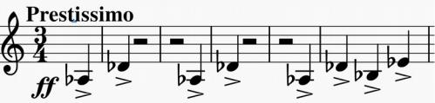

(*illustrated*) brings to mind the nightmarish night music

of the second movement of Britten's 1945 Second Quartet. Had Ligeti heard the Britten or were both independently inspired by Bartók?

The variations are extraordinarily brilliant, virtuosic and inventive in their sounds, using the full range of string technique, including Bartók's 'snap' pizzicato. Ligeti's exact ear and sensitivity to string technique perhaps came down from his paternal great-uncle the great Hungarian violinist Leopold Auer, founder of the Russian school of violin playing and teacher of Elman and Heifetz.

After fleeing Hungary following the brutal suppression of the 1956 uprising, Ligeti was freed from the state control of his musical expression, only to be confronted by the avant garde ideologues of the Darmstadt-Cologne School . Although he lectured at Darmstadt and provided a classic analysis of the apogee of hard-core serialism - Boulez's *Structures 1a -* by both nature and experience he was suspicious of system and dogma. His ownmusic incorporated whatever it needed whether serially approved or not. He avoided the retrospective lure of postmodernism, looking instead to Caribbean, central African and East Asian music for fresh sounds. These led him back to revisit and republish many of his previously concealed youthful compositions. *(Paul Griffiths' entry on Ligeti in Grove was invaluable in preparing this note).*

INTERVAL

**Franz Schubert (1797-1828) String Quartet in D minor, D.810 (Death and the Maiden)**

**(1824)**

*Allegro*

*Andante con moto*

*Scherzo: Allegro molto*

*Presto*

Though composed in the same year as the A-minor "Rosamunde" quartet, the opening four bars of this D minor quartet set it in a

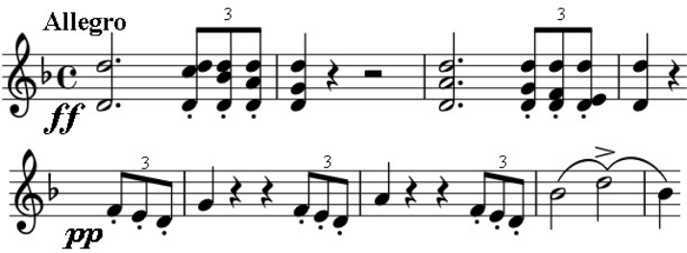

different world from Rosamunde's understated charms. The hammered out *fortissimo* triplet figure (*illustrated*) demandsour serious attention, but is immediately transformed into an almost apologetically tender *pianissimo* phrase (*illustrated* ). After a pause, the tension mounts, driven by the triplets, to a reinforced version of the opening.

This emotional roller-coaster continues throughout the movement. The triplets sometimes give way to the dotted rhythm of a yearning tune (*illustrated*) that Jack Westrup attributes to Schubert's admiration for Rossini; this

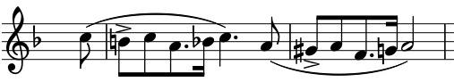

theme in turn gets transformed into more serious matter against running semiquavers. The emotional intensity and tightness of

construction of the movement recall the later Beethoven but it was written the year before the first of Beethoven's late quartets. The repeated notes of the opening bars and their rhythm are echoed in the themes of the other three movements.

The theme for the variations of the G minor *Andante con moto* comes from Death's contribution to a short Schubert song of 1817,

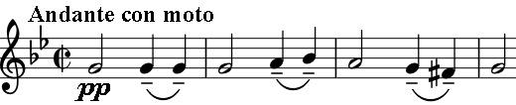

inviting a terrified young girl to sleep safely in his arms. The quartet version is lighter: a fourth higher and *con moto*. The calm of the first two

variations is shattered by the brutal dactyls (–˅˅) of the third, in a more rapid version of the rhythm of the theme; calm returns only to be broken again by the long *crescendo* of the repeat of the fifth variation to yet more terrifying dactyls. The terror subsides to a serene end and a Schubert-hallmark switch to the major.

The fiercely syncopated energy of the *Scherzo* contrasts with a tranquil *Trio*,whose D-major theme (*illustrated*) is related to the work's opening. The *Scherzo* leads to

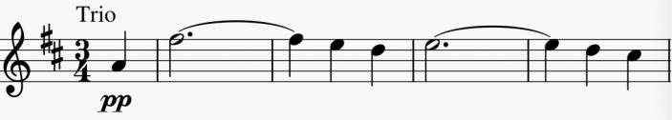

the tarantella-form *Presto* finale. The tarantella folk-dance hails from Taranto in southern Italy: a courting couple dance encircled by others as the music gets faster and faster. Taranto independently gave its name to the tarantula spider, the effects of whose allegedly serious bite could, it was thought, be ameliorated by wild dancing. Pepys records tales of itinerant fiddlers cashing in on this belief especially during the harvest when bites were more frequent. It is quite possible that Schubert intends the allusion to cheating death, but either way this energetic dance with its *prestissimo* ending provides a rousing climax to the quartet.