**Programme Notes by Chris Darwin**

**Leoš Janáček (1854-1928) 'Mládí' Suite for Wind Sextet JW VII/10 (1924)** *Allegro*

*Andante sostenuto*

*Vivace*

*Allegro animato*

Mládí (Youth) was written in the middle of Janáček's immensely productive last decade. His productivity had both political and personal roots: Czechoslovakia had become independent in 1918 and the previous year Janáček had met and fallen in love with the much younger Kamila Stösslová. Kamila is explicitly associated with the gypsy femme fatale of his song cycle 'The diary of one who disappeared' (1917), as well as with the heroines of his operas 'The Cunning Little Vixen' (1922-3) and 'The Makropoulos Affair' (1923-5).

The wind sextet Mládí (along with his first string quartet) was written around the same time as these operas, and shares with them the technique of shaping individual phrases to the prosody of the speaking voice. The oboe's

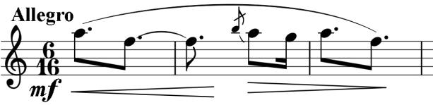

opening phrase captures the phrase 'Mládí, zlaté mládí!' ('Youth, golden youth!') and recurs throughout the work especially in the first and last movements.

The third movement borrows a theme from a short work Janáček composed earlier in 1924 for piccolo, bells and tambourine 'March of the Blue Boys', recalling his time as a chorister in the Old Brno Monastery.

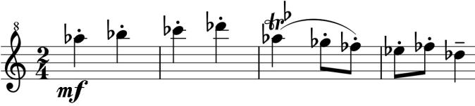

Mládí's first performance, in Brno, was given by teachers at the Conservatory there and was plagued by mechanical failure: the oboe had to effect an impromptu repair; he was more successful than the clarinettist who, because of a broken spring, could only pretend to play. Janáček's understandable anger abated a month later with a successful and popular performance in Prague by members of the Czech Philharmonic.