**Programme notes by Chris Darwin – please use freely for non-profit activities**

**Leoš Janáček (1854-1928) String Quartet No.1 (Kreutzer Sonata) (1923)**

*Adagio - Con moto*

*Con moto*

*Con moto - Vivo - Andante*

*Con moto - (Adagio) - Più mosso*

George Bridgetower was a Polish -African violinist, a friend of Beethoven and the original dedicatee of his tempestuous A major violin sonata '*Sonata per un mulattico lunatico'*. Shortly after the first performance in 1803, Bridgetower insulted a woman-friend of Beethoven, who then changed the sonata’s dedication to Rodolphe Kreutzer. Kreutzer didn’t much care for Beethoven’s music and never played the '*outrageously unintelligible'* sonata. This 'Kreutzer' Sonata inspired a novella (1889) by Leon Tolstoy in which a husband’s jealousy is inflamed by his wife playing the sonata with an attentive male violinist. Arriving home unexpectedly one night, the husband finds the pair together in the music room and stabs his wife to death. The violinist escapes (undignified to chase him in one’s socks); the distraught, guilt-ridden husband, acquitted of murder, rides the trains seeking the forgiveness of strangers.

In 1907-9 Janáček had been inspired both by Tolstoy's *Anna Karenina* and by his *Kreutzer Sonata*. Unfortunately, not only his sketches from *Anna Karenina* but also the complete three-movement Piano Trio inspired by the *Kreutzer Sonata* have been lost. Much later in 1923, Janáček returned to the topic of the *Kreutzer Sonata* producing his first string quartet. We have Janáček's word, corroborated by Pavel Dĕdeček the violinist at the first performance of the lost piano trio, that some of the ideas from the piano trio gave rise to the quartet. The quartet was written in just a fortnight in October 1923 in Janáček’s characteristic fragmentary, episodic, mature style; it swings the listener violently across a huge range of emotions. By then the 69-year old Janáček was having a musically productive but one-sidedly passionate and obsessive (730 letters) relationship with Kamila Stösslová, a married woman 38 years his junior. He wrote to her: *'I was imagining a poor woman, tormented and run down, just like the one...Tolstoy describes in his Kreutzer Sonata' .*

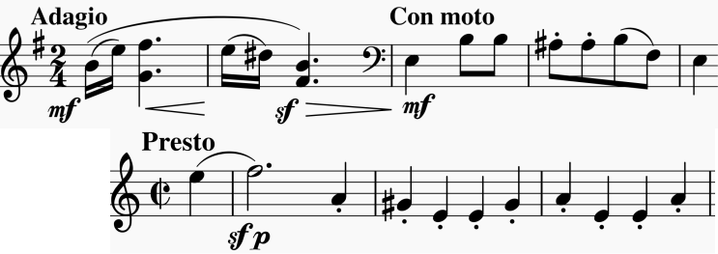

The opening contains two elements: a slow (*Adagio*), anguished, rising and falling motif on the violin and viola, followed immediately by a faster (*Con moto*), busy motif on the cello. These twoelements dominate the first movement, taking on a variety of forms, and recur throughout the work. It is perhaps not too fanciful to see their link with the

opening *Presto* of Beethoven's original 'Kreutzer' violin sonata (also illustrated). Tolstoy's jealous husband was particularly wary of its power: *"..how can that first presto be played in a drawing-room among ladies wearing low-necked dresses? … [it leads to] an awakening of energy and feeling unsuited both to the time and the place."*

The second movement, in the remote 7-flats of Ab minor, starts with a speeded version of the earlier falling motif and soon leads us into a frighteningly icy world of *tremolo* played *sul ponticello*

– close to the bridge. The ice melts into the 5 sharps of B major with faster relentless triplets. The *Con moto* opening of the third movement echoes the second subject of Beethoven's opening *Presto* (illustrated); its timidness is interrupted by more of Janáček's scary *sul ponticello.* The final movement starts calmly with thework's opening, rising motif, but the energy rises relentlessly with fast accompanying figures that become a manic gallop to the exhausted end.

