**Programme notes by Chris Darwin. Please use freely for non-commercial purposes.**

**Joseph Haydn (1732 - 1809) Piano Trio in A flat, Hob. XV:14 (1790)**

*Allegro moderato*

*Adagio*

*Rondo (Vivace)*

Haydn wrote about 45 piano trios throughout his life, starting in his early 30s and ending in 1797 when he was 65. They demonstrate his inventiveness in creating new musical structures, and also his harmonic adventurousness. Charles Rosen described them as *'along with the Mozart concertos the most brilliant piano works before Beethoven.'* Rosen's emphasis on the piano is apt, since the cello very often doubles the keyboard bass, necessarily compensating for the thin tone of the harpsichord or of the contemporary early pianofortes; the violin though carries a more independent line.

This Ab Trio is contemporary with his Op 64 string quartets and dates from 1790, the year that Haydn, released from many of his obligations at the Esterhazy palace, first visited London. The work was probably composed for the new pianoforte; we know from a letter that Haydn wrote to his publisher Artaria in 1788 that he was then composing a set of trios at a 'grand pianoforte' rather than at the harpsichord.

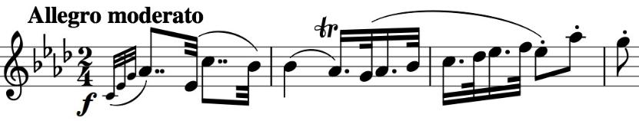

The opening theme (illustrated) has an assertive dotted rhythm which dominates the first part of the movement; it contrasts with a

smoother, gentle version of a rising scale. At the double bar Haydn ominously shifts this rising figure, now *forte*, through various minor keys for a few bars; he then plays one of his favourite tricks – the music just stops. After two silent bars it starts again in a completely different mood. The keys become extreme, before returning to the home key for the last part of the movement.

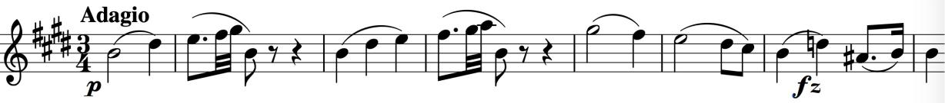

The beautiful slow opening melody of the *Adagio* (illustrated) shows Haydn's genius at melting our hearts by the simplest of means. This poignant melody sandwiches a rhapsodic outburst in the minor from the piano, minimally accompanied by pizzicato strings. The work ends with a good-natured Rondo.