Programme notes by Chris Darwin. Use freely for non-commercial purposes

**Joseph Haydn (1732-1809) Piano Trio in E**-**flat Hob XV: 30 (1797)**

*Allegro moderato*

*Andante con moto*

*Presto*

It is easy to undervalue Haydn's Piano Trios. The string parts often double the keyboard and generally lack the independence found later, say in Beethoven. But for much of his piano trio output, Haydn's hands were tied by the underpowered keyboards that he was writing for – doubling of the weak keyboard bass line in particular was a necessity. Viewed on their own terms as 'keyboard sonatas with string accompaniment', we can enjoy their many virtues rather than wishing they were Beethoven.

Charles Rosen devotes a whole chapter of 'The Classical Style' to Haydn's piano trios encouraging us to see them as a "*third great series of works to set beside the symphonies and the quartets* ". They fall into two main groups: 16 or so early trios composed betweenabout 1760 and the early 1770s, and the latter 27 or so composed between 1784 and 1797. In all of them Haydn is surprising and inventive. In the earlier trios his natural extroversion sits well with the excesses of the contemporary Mannerist style – as in say C.P.E.Bach. But in Haydn's later trios his creative exuberance acquires new significance thanks to the structures of the newly emerging Classical style.

Today's E-flat trio comes after visits to London where he was inspired both by virtuosi such as Theresa Jansen-Bartolozzi and also by the more powerful new Broadwood pianos. It is a work of extraordinary inventiveness and surprise and is probably the last piano trio he wrote (around the same time as the Op 76 string quartets). Why did Haydn write no more piano trios after 1797? Partly because he had left London with its talented pianists and forceful Broadwoods, but also Beethoven's revolutionary three Op 1 piano trios had appeared two years earlier in 1795. Haydn knew when he had been overtaken.

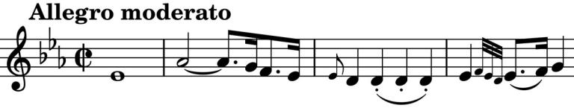

The first movement opens quietly with a

theme that sounds as though it is still

finding its way: four simple bars

(*illustrated*) then a questioning repeat, a

two bar answer, another questioning bar, and then another. The piano bursts out into semiquaver runs and the strings produce a new melodic line based on the opening. These opening thoughts provide material for a movement full of melodic ideas and harmonic surprises. For example, the exposition ends decisively in the two flats of B-flat major. But after just four bars of the development we are equally firmly in the challenging seven flats of C-flat major.

The C major slow movement contrasts two moods: the rather stately opening with a more animated section driven along with rapid scales. The repeated notes on violin in the simple opening (*illustrated*) recall the third and fourth bars of the first movement. Both this violin phrase and

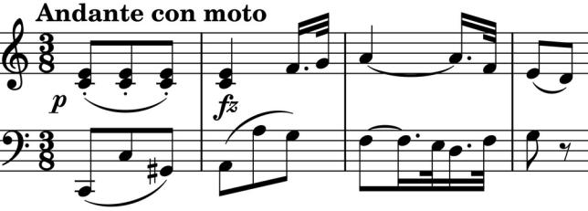

the beautiful rising figure on cello contribute to the melodic development of the movement. The stately and the animated interrupt each other, until a pause in the stately that seems to be leading to another return of the animated instead leads straight into the boisterous

*Presto*. The first section with its jaunty theme (*illustrated*) is interrupted by a sudden shift to the 6 flats of E-flat minor with an insistent them again based on the repeated notes of the work's opening. The major theme gleefully returns and with a bravura show of rapid triplets Haydn signs off from the piano trio.