**Programme notes by Chris Darwin: Use freely for non-commercial purposes**

**Joseph Haydn (1732-1809) Piano Trio in Eb, Hbk. XV:29 (1795)**

*Allegro moderato*

*Allegretto*

*Finale: Allegro*

It is easy to undervalue Haydn's Piano Trios. The string parts, particularly the cello, often double the keyboard and generally lack the independence found later in say Beethoven. But for much of his piano trio output, Haydn's hands were tied by the underpowered keyboards that he was writing for – doubling of the weak keyboard bass line was a necessity. Viewed on their own terms as 'keyboard sonatas with string accompaniment', we can enjoy their virtues rather than wishing they were Beethoven.

Charles Rosen devotes a whole chapter of "The Classical Style" to Haydn's piano trios encouraging us to see them as a "third great series of works to set beside the symphonies and the quartets". They fall into two main groups: 16 or so early trios composed between about 1760 and the early 1770s, and the latter 27 or so composed between 1784 and 1797. In all of them Haydn is surprising and inventive. In the earlier trios his natural extraversion sits well with the excesses of the contemporary Mannerist style. But in Haydn's later trios his creative exuberance acquires new significance as it is constrained by the structures of the newly emerging Classical style.

Tonight's E-flat major trio, is one of three dedicated to the virtuoso pianist Theresa Jansen Bartolozzi whom he had met in London. It is one of the last trios he wrote (around the same time as the Op 76 string quartets), and exploits the more powerful Broadwood pianos that were then available in England. Broadwoods freed the cello in particular from merely doubling the bass line of the keyboard part giving Haydn more scope to transcend the limitations of the "accompanied sonata". Why did Haydn write no more piano trios after this set? Partly because he had left London with its talented pianists and forceful Broadwoods, but also perhaps because Beethoven's revolutionary three Op.1 piano trios had appeared in 1795. Haydn knew when he had been overtaken.

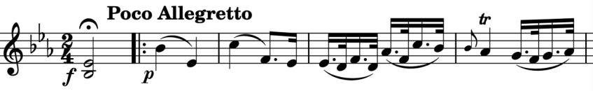

The work opens with a forte held chord – to shut the audience up and encourage

them listen to to the quiet entry of the graceful motif that dominates the movement: two pairs of falling fifths and a rising dotted figure ( *illustrated*). Robert Philip describes it as having a 'mock-ecclisastical air, with its dignity punctuated by sudden accents and flourishes'. A middle section moves into the six flats of E-flat minor and the violin enjoys some melodic freedom before a return to the familiar territory of the major. The final section of the movement gives Mrs Bartolozzi's piano its flamboyant head.

The slow movement might have simply added another flat to the earlier six to give us the seven of C-flat major, but Haydn takes pity on the players and gives them the enharmonic equivalent – 'just' the five sharps of B major. Its lovely, spacious melody looks like the material for an extensive movement but Haydn, ever surprising, denies us by all too soon swerving back into E-flat and after a brief piano cadenza whisking us off into the boisterous *Finale: Presto assai* (very fast) *in the German style*. After 30-odd bars Haydn gives the pianist an accented 4-quaver phrase repeated 5 times across 6-quaver bars (*illustrated*), but takes pity and explicitly numbers them 1 to 5 observing that at a *Presto*

tempo *'the performer will find great facility by reckoning the Numbers in mind while playing the passages thus marked'*. How kind!

