Programme notes by Chris Darwin. Use freely for non-commercial purposes

**Josef Haydn (1732-1809) String Quartet in F, Op 77 no 2 (1799)**

*Allegro moderato*

*Menuet & Trio: Presto*

*Andante*

*Finale: Vivace assai*

Prince Razumowsky's sister-in-law Lulu had this to say of Josef, the 7th Prince Lobkowitz: *"This Prince was as kindhearted as a child and the most foolish music enthusiast. He played music from dusk to dawn and spent a fortune on musicians. Innumerable musicians gathered in his house, whom he treated regally."* Pity we don't get many likethat these days. We have Lobkowitz to thank for commissioning six string quartets from Haydn. However, the ageing Haydn, pre-occupied with writing *The Seasons,* completed only two of the six. These two Op 77 quartets are a worthy climax to Haydn's quartet writing. The first is triumphantly in the tradition of 'first violin' quartets, whereas the second has in Rosemary Hughes' words: 'that pure, linear string-quartet writing in which each instrument brings its strand of melody, clear and distinct, to the texture of the whole'.

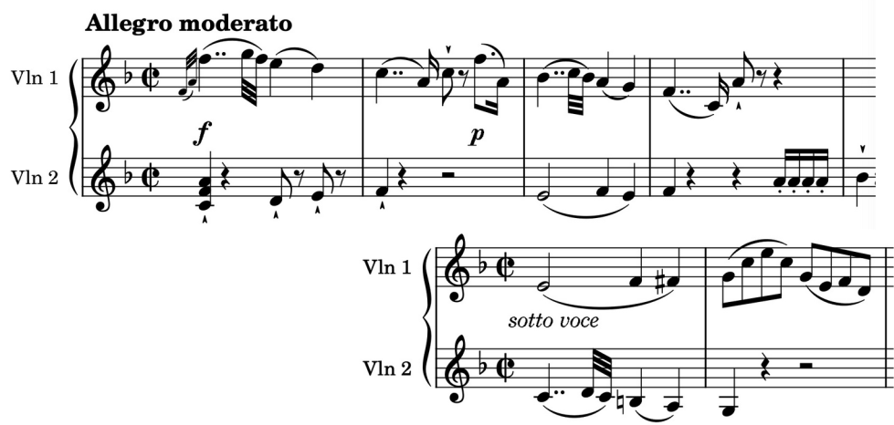

The opening of today's quartet demonstrates Haydn's renowned thematic economy. The first violin has the theme while the second violin accompanies with a

simple rising figure (*illustrated*). After 30 -odd bars the second theme appears in the first violin, as a version of what the second violin had previously played, while the second accompanies with a version of the first's opening theme (*illustrated*) .

Nominally a *Menuet*, the *Presto* second movement is a scherzoid romp sandwiching a gravely tender *Trio*. The opening derives much of its energy from three-beat bars trying to accommodate a tune that wants to be in two. The *pianissimo Trio* is in the unconventional key of B-flat minor and unusually has a coda. This coda sounds as if the *Menuet* is returning (albeit *pianissimo* and in D -flat major) but turns out to be a witty excursion on the way back to the *Menuet's* home key of F major.

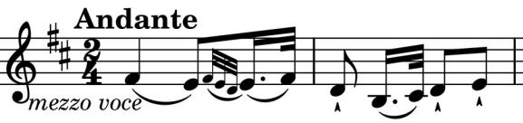

Delaying the slow movement until after the *Menuet* is a sign that we are in for something special. The cello sets out on its D-major *Andante* walk accompanying just the first violin in a theme (*illustrated*) that is a close

relative of the start of the first movement. The other two members of the quartet then join them for a magical harmonisation. Variations on this theme follow: second violin gets the theme, with viola doing the walking, and then after a pregnant chord, the cello gets the theme while the first violin takes off on an extended cadenza that after a dramatic climax brings us back to a *pianissimo* final appearance of the theme.

Haydn now has a problem – the *Andante* ended firmly in D (with a prominent F-sharp), which is not a good precursor to the last movement's chirpy tune in F. He solves it simply by serving us a palate-cleansing F-major chord. We are now ready for the upcoming

Polonaise-style Finale, so off we go dancing (monothematically of course) to the end of Haydn's last completed quartet.