**Program Notes by Chris Darwin. Please use freely for non-commercial purposes.**

**Josef Haydn (1732-1809) String Quartet in E**♭ **Op 76 no 6 (1797)**

*Allegretto*

*Fantasia: Adagio*

*Menuetto: Presto, Alternativo*

*Finale: Allegro spiritoso*

In 1795 Haydn returned from his spectacularly successful visits to England to the relatively light duties prescribed by the new Esterházy Prince Nikolaus II. Nikolaus had abandoned his father's palace at Esterházy, sacked its extensive musical establishment, and divided his time between Eisenstadt and Vienna. Haydn was kept on, but his main duty was just to write a Mass for the Princess's name day. He was free to accept other commissions.

One such came from Count Joseph Erdödy, the Hungarian Court Chancellor. Although Erdödy's father had employed an orchestra to play in their family's three palaces, on inheriting the title in 1789 his son responded both to contemporary taste and financial stringency by replacing it with a string quartet. In 1796 he placed a generous commission with Haydn for six quartets. The resulting 'Erdödy' quartets are a triumph, perhaps the pinnacle of Haydn's long quartet-writing career.

Ever since Haydn had invented the mature string quartet in his Op 20 group of 6 quartets he had been experimenting with its form. Today's quartet is no exception. The first movement is a leisurely Allegretto

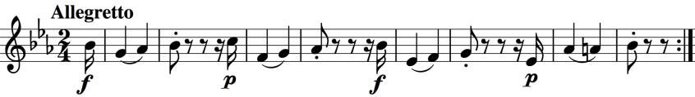

cast as a theme and variations. The theme (illustrated) is a sequence of 'laconic phrases until

the lilting expansive cadence of its final bars' (Rosemary Hughes). Notice that each of the illustrated four initial phrases contains three notes of a rising scale. This scale motif is central to the whole quartet. Three variations at the leisurely Allegretto tempo follow before the starting gate is raised on an Allegro fugue which then metamorphoses into a final variation.

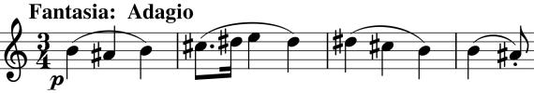

Haydn is disingenuous with the Fantasia second movement. Unlike Mozart who rarely strayed

outside key signatures of 3 sharps or flats, Haydn was given to writing in lots of them. This movement is really in B major – 5 sharps, but it starts (illustrated) with no key signature albeit with the notes liberally sprinkled with sharps. Was this a riposte to complaints from his players about dreadful keys, or is the lack of key signature granting him licence for his upcoming fantastic explorations of the key-space? These explorations are facilitated by a series of four rising scales (echoing both the start of this movement and of the first movement) first on the violin and then on the cello. They lead the music off all around the block to Ab before a second lot of cello scales brings us home to a proper key signature of B major. The second half gives us a serene and poignant development of the theme.

Scales continue to figure in the scherzo-like Menuetto, but return in spades for its 'Alternativo' trio section which consists

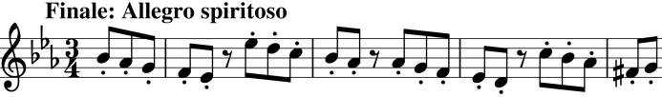

of almost nothing else, sometimes rising, sometimes falling. Four falling

scales also make up the theme of the spirited final movement (illustrated).