**Programme notes by Chris Darwin. Use freely for non-commercial purposes**

**Josef Haydn (1732-1809) String Quartet in G Op 76 No 1 (1797)**

*Allegro con spirito*

*Adagio sostenuto*

*Menuet: Presto*

*Finale: Allegro ma non troppo*

In 1795 Haydn returned from the last of his spectacularly successful visits to England to the relatively light duties prescribed by the new Esterházy Prince Nikolaus II. Nikolaus had abandoned his father's palace at Esterházy, sacking its extensive musical establishment, and divided his time between Eisenstadt and Vienna. Haydn was kept on, but his main duty was just to write a Mass for the Princess's name day. He was free to accept other commissions. One such came from Count Joseph Erdödy, the Hungarian Court Chancellor. Although his father had employed an orchestra to play in the family's three palaces, on inheriting the title in 1789 Count Joseph responded both to contemporary taste and financial stringency by replacing the orchestra with a string quartet. In 1796 he placed a generous commission with Haydn for six quartets. The resulting Erdödy quartets are a triumph, perhaps the pinnacle of Haydn's long quartet-writing career.

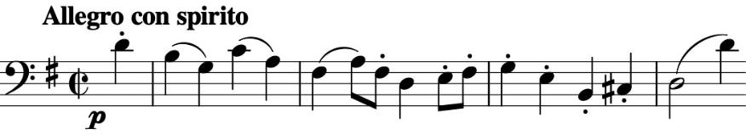

Today's G major quartet opens with a dramatic new gesture: three dense, forte chords calling our attention to the

subsequent *piano* single line of the cello's phrase (*illustrated*). The viola answers, completing the theme which is then repeated as a cello/violin duo. Not until bar 17 is the full quartet requisitioned. What follows is a masterpiece of transparent contrapuntal writing.

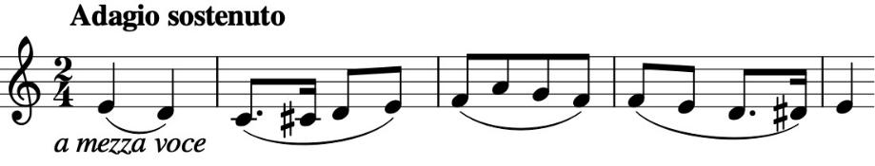

The start of the *Adagio sostenuto* really is *sostenuto,* serenelysmoothing our troubles away, the two dotted notes

paradoxically increasing the effect (*illustrated* ). But then the first violin decorates the theme with running demi -semiquavers which turn into a rapid off-beat riff and the rest of the movement develops the contrast between these two ideas.

Now for the *Menuet*; well, no. Haydn had previously played with the '*Menuet*' movements in his Op 33 quartets labelling them *Scherzo* and giving them *Allegretto* or *Allegro* tempi. Beethoven had meanwhile adopted *Scherzi* with varieties of *Allegro* in his Op 1 Piano Trios; but now Haydn retaliates with a *Menuet* that is marked *Presto* and is completely un-danceable. It contrasts with a jokey retro Ländler-like trio.

And finally, yet another Haydn first. It is not unusual for a piece that is predominantly in the minor to have its last movement in the major, providing a joyful liberation from the worries of the minor and applause to match. But Haydn, the indefatigable experimentalist, paradoxically does the reverse in order to get an enhanced effect. The last movement of this G major quartet starts in G minor, with a

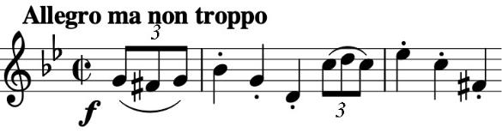

tense, angry theme (*illustrated* ), all the more so in contrast with the serenity and fun that

has passed. The tension builds, until three-quarters of the way through the movement there is a moment of unique catharsis. We go into the major (*illustrated*). Hans Keller asks rhetorically : "Is it the first time in the history of composition that a work's... utterly unexpected culmination ensues at this late stage in the development of its structure...?".

