**Programme Notes by Chris Darwin. Use freely for non-commercial purposes**

**Josef Haydn (1732-1809) String Quartet in C Op 76 no 3 'Emperor' (1797)** *Allegro*

*Poco adagio; cantabile*

*Menuetto. Allegro*

*Finale. Presto*

In 1795 Haydn returned from his spectacularly successful visits to England to the relatively light duties prescribed by the new Esterházy Prince Nikolaus II. Nikolaus had abandoned his father's palace at Esterházy, sacking its extensive musical establishment, and divided his time between Eisenstadt and Vienna. Haydn was kept on, but his main duty was just to write a Mass for the Princess's name day. He was free to accept other commissions. One such came from Count Joseph Erdödy, the Hungarian Court Chancellor. Although Erdödy's father had employed an orchestra to play in their family's three palaces, the son, on inheriting the title in 1789 responded both to contemporary taste and financial stringency by replacing it with a string quartet. In 1796 he placed a generous commission with Haydn for six quartets. The resulting Erdödy quartets are a triumph, perhaps the pinnacle of Haydn's long quartet-writing career. The best known of the six is tonight's Emperor Quartet, named for the slow movement's theme, which Haydn wrote in praise of Emperor Francis II and which become the Austrian and then the German national anthem.

For those of us who find our own national anthem musically uninspiring, it is ironic that it inspired Haydn to write the glorious melody that became the German one. While in England, he had envied the British nation its ability to express, through song, devotion to its ruler. On his return to Austria he convinced the President of Lower Austria to commission a similar anthem to enhance devotion to the Emperor particularly in the face of the threat of the invading French. A lapsed Jesuit freemason Lorenz Leopold Haschka wrote the words of the Kaiserhymne ("Gott erhalte Franz den Kaiser..."*)* and Haydn the music - "*the only man capable of creating something that could be placed at the side of ... God Save the King*".

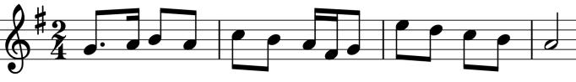

The origin of the first line of Haydn's tune could have been a rather simpler north Croatian folksong (illustrated), but Haydn's version (illustrated) subtly shifts the bar line and changes the end. Haydn worked hard on the rest of the melody, particularly on

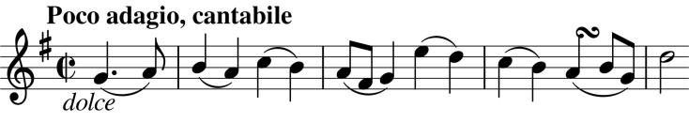

the apparently effortless climax. The investment paid off and the Kaiserhymne achieved extraordinary fame, not to mention helping to defeat the French. It was also a favourite of the composer's. He frequently consoled himself with it during his final decline, and it was the last thing he played, five days before his death. Each instrument gets to play the melody as the four variations unfold, as if taking turns to pay homage to the Emperor.

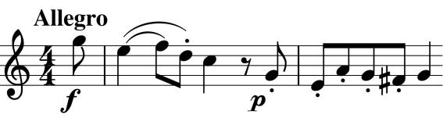

The words of the Anthem mould the opening notes of the first movement's theme (illustrated). G-E-F-D-C (aka K) are an acronym for: *Gott erhalte Franz den Kaiser.* London also makes a wider

contribution. While there he was exposed to larger orchestras and larger halls and audiences. Consequently, his late quartets have a richer, fuller sound than their predecessors.