**Programme notes by Chris Darwin. Use freely for non-commercial purposes**

**Josef Haydn (1732-1809) String Quartet in G (minor) Op 74/3, ‘Rider' (1793)**

*Allegro*

*Largo assai*

*Menuet and Trio*

*Finale: Allegro con brio*

Haydn’s six 'Apponyi' quartets (Ops 71 and 74) were written in 1792 & 1793 between his two extended visits to London. Prince Nicholas Esterházy, Haydn’s patron to whom he was devoted, had died in the autumn of 1790. His successor, Prince Anton, did not care for music and disbanded the Esterházy orchestra, for whom Haydn had composed for the previous 30 or so years. However, he did keep Haydn on, on full pay, with only nominal duties. Haydn was thus free to apply for leave to accept Johann Peter Salomon’s offer to spend a year in London (against Mozart’s advice, who thought the 58 year-old master too old for such jaunts). London's crowded, vibrant musical scene challenged and exhilarated Haydn, and his six new 'London' symphonies, written for a larger orchestra, hall and audience than at Esterházy, were a sensation. Haydn returned home in the summer of 1792, to a Vienna without Mozart, who had died in December just short of his 36th birthday.

The eponymous Apponyi, Count Anton Georg, was a relative of the Esterházys, and paid Haydn 100 ducats for the privilege of having the six quartets publicly dedicated to him. The quartets of the set have a power and brilliance that reflect Haydn’s experience with the London orchestras and his intention to take the quartets back to his London audience.

Hans Keller in '*The Great Haydn Quartets'* highlights the many original features of the 'Rider' quartet. One of them relates to its key – G minor, so they say. But Keller makes the case for it being in both G minor *and* G major: it is '*musical history's first work centred on a home tonality rather than a home key'*. (Compare Beethoven's use of E in his secondRazumovsky quartet after the interval). Another novelty is its opening. All six Apponyi quartets have an introduction – mostly very short and attention gathering. But the Rider is different. Are the equestrian opening 8 bars an introduction or not? After them the music stops for almost 3 bars and then restarts with related but quite different material. That sounds like an introduction. But the opening (illustrated) gives seed material for much of the rest of the quartet, and is

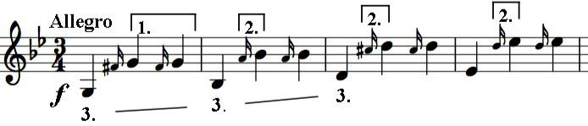

used explicitly in the development, so it could be regarded not as an introduction but as the exposition of the main subject: short but

significant. As so often with Haydn's structures, expect the unexpected.

At least three features of this opening recur in many guises: [1] the upbeat of two repeated notes, [2] the semitone from the grace note, and

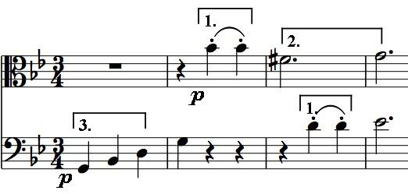

1. the three notes of the minor chord that start the first three bars (G, Bb, D). For example, they all feature immediately on cello and viola at the restart after the 'Introduction' (illustrated). A more contrasting idea soon appears: a running triplet figure; but even this is introduced by the repeated upbeat [1], as is the dotted-rhythm second theme. The fact that different themes

and episodes are built from the recombination of a few simple elements gives the work a satisfying integrity even when you are unaware of the mechanics of its construction. The key moves to G major for the last 30 bars of coda, ending with a G in the first violin. Its next note, the first of the slow movement is a shocking G sharp, a semitone higher; the key is now E major (illustrated).

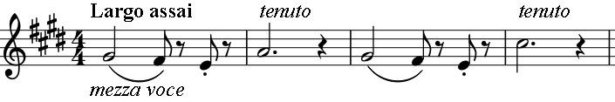

As in the opening of the first movement, Haydn again plays with the idea of a pause, holding the fourth note

of the opening phrase to dominate the second bar. This deeply serious movement moves into E minor in the middle section with an upside-down version of the opening bar. Back to E major but now the serious mood is taunted by unsettling, bizarre episodes: the first violin plunging unexpectedly down a scale, all four instruments breaking into fluttering, pianissimo demi-semiquavers for 2 bars. But the fiends dissolve and the movement ends serenely.

The otherwise relatively straightforward third movement supports Hans Keller's views about the quartet not really being in G minor: the Minuet is in G major and the Trio in G minor rather than the conventional other way round. The lively (and also equestrian) last movement rattles along initially in G minor with a theme that echoes the repeated upbeats of the first movement; Haydn plays with pauses again before switching to G major for the gallop to the finish.