**Josef Haydn (1732-1809) String Quartet Op. 74 No.1 in C (1793)**

*Allegro*

*Andantino grazioso*

*Menuet & Trio*

*Finale: Vivace*

Haydn’s six 'Apponyi' quartets (Op 71 and 74) were written in 1792 & 1793 between his two extended visits to London. Prince Nicholas Esterházy, Haydn’s patron to whom he was devoted, had died in the autumn of 1790. His successor, Prince Anton, did not care for music and disbanded the Esterházy orchestra, for whom Haydn had composed for the previous 30 or so years. However, he did keep Haydn on, on full pay, with only nominal duties. Haydn was thus free to apply for leave to accept Johann Peter Salomon’s offer to spend a year in London (against Mozart’s advice, who thought the 58 year-old master too old for such jaunts). London's crowded, vibrant musical scene challenged and exhilarated Haydn, and his six new 'London' symphonies, written for a larger orchestra, hall and audience than at Esterházy, were a sensation. Haydn returned home in the summer of 1792, to a Vienna without Mozart, who had died in December just short of his 36th birthday. The eponymous Apponyi, Count Anton Georg, was a relative of the Esterházys, and paid Haydn 100 ducats for the privilege of having the six quartets publicly dedicated to him. The quartets of the set have a power and brilliance that reflect Haydn’s experience with the London orchestras and his intention to take the quartets back to his London audience.

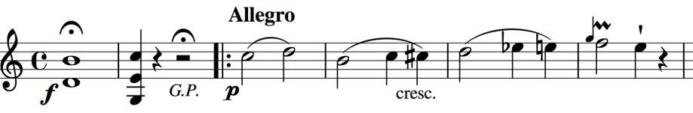

Like the three preceding Op 71 quartets, this quartet opens with a short introduction:

apparently a simple C-major cadence establishing the key. But its importance turns out to be melodic rather than harmonic as its ascending B-C

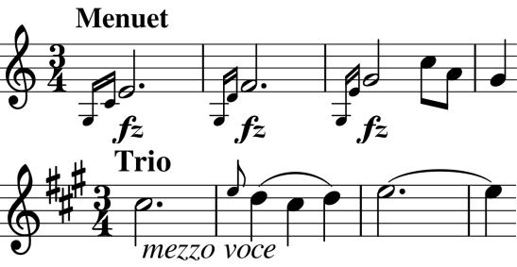

semitone sequence breeds no fewer than 6 ascending semitones in the following Allegro theme. Haydn's love of thematic integrity also appears in the Trio's echoing of the Menuet's rising theme. The same rising figure moulds the theme for the brilliant fugally-developed Finale.