Programme Notes by Chris Darwin – use freely for non-profit activities

**Josef Haydn (1732 – 1809) String Quartet in B Minor, op. 64, no. 2 (1790)** Allegro spiritoso

Adagio ma non troppo

Menuet & Trio: Allegretto

Finale: Presto

This quartet is one of Haydn's 12 “Tost” quartets. From 1783 to 1788 the Hungarian Johann Tost was principal second violin in the Esterházy orchestra of which Haydn was music director. When Tost left Esterházy in 1788 to freelance in Paris, Haydn entrusted 6 quartets to him with a view to finding a publisher. Tost was successful, and they were published in Paris in two sets of three as Op 54 and 55. A later set of six, Op 64, were written in 1790, the year that Haydn first visited London. Around this time Tost returned from Paris, married the housekeeper at Esterházy (of whom Haydn was also fond) and used her money to set up a successful cloth business in Vienna. There in 1791 he also found a publisher for the Op 64 set, which Haydn gratefully dedicated to him. Tost continued to play the violin and commission chamber works, especially from Spohr, whose performances in aristocratic homes provided an entrée for his cloth business; incidentally he is possibly also the dedicatee (*"composto per un amatore ongarese")* of the last two of Mozart's string quintets.

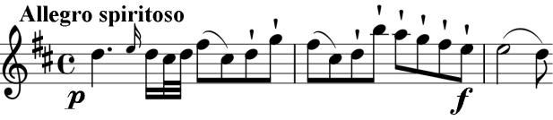

The first movement of the B minor quartet, like many Haydn movements, is built almost entirely from the opening material. Its various elements are reworked and

reassembled into a wealth of related ideas. The cautious uncertainty of the opening develops into a skittish end to the first half, but then its ominous undertones become angrier and develop into a dark and powerful climax with double octave leaps from the first violin.

The slow movement, in the radiant 5 sharps of B major, bears Haydn's recommendation that the second violin has '*a*

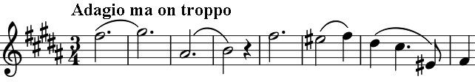

*good and secure intonation*'. Above its tricky arpeggios the first violin floats a serene theme,

subsequently decorated in beautiful variations. The dark side returns with the hard-edged minor key Menuet; it is contrasted with the blithely soaring B major Trio. The same major-minor contrast occurs in the very fast last movement, whose somewhat threatening B minor theme is transformed, shortly before the end into a buoyant B major. Curiously, Haydn ends the movement with 2 bars rest for all the players, an encouragement perhaps to follow his instructions to repeat the second half.