**Programme notes by Chris Darwin. Use freely for non-commercial purposes**

**Josef Haydn (1732-1809) String Quartet in G Op 33 no 5 (1781)**

*Vivace assai*

*Largo e cantabile*

*Scherzo: Allegro*

*Finale: Allegretto*

In the course of the five years from 1768 to 1772, Haydn published three sets of quartets, the Op 9, 17 and 20, in which the older Divertimento form evolved into the true string quartet with free and independent parts. During the previous decade, the exercise of manufacturing over a hundred Trios for viola, cello and Prince Esterhazy's baryton had schooled Haydn in writing for individual string parts without an accompanying harpsichord. This technical facility, his extraordinary structural genius, and the continued maturing of his creative powers happily came together to produce in the Op 20 quartets six works of revolutionary genius.

But then Haydn wrote no more quartets for a decade, until the Op 33 set of six in 1781. Probably all his energies were used directing the music for 50 operas (five his own compositions) and various marionette productions at the Esterhazy palace. In 1779 the Prince engaged a lively young singer, Luigia Polzelli, with whom Haydn developed a passionate relationship. Whether she served as a stimulus or a distraction, or even both, is not known, but by 1780, energy flowed back into his symphonies and Haydn started to compose string quartets again.

He announced the Op 33 set to potential subscribers as "*brand new à quadro ... written in a new and special way, for I have not composed any for ten years*". This advert wasmaybe a bit of a come -on to revive the market, but the new set are altogether more relaxed and confident than the Op 20s. They have jokey Scherzi rather than Minuets, less Sturm und Drang, more major than minor and a variety of different finale forms replacing Op 20's intellectual fugues. The Op 33 set appeared in Vienna just as the 26 year-old Mozart arrived there in pursuit of a freelance career. Haydn's new quartets catalysed Mozart into writing more quartets of his own, resulting in the famous set of six that he dedicated to Haydn. The second of these Mozart quartets (in D minor) has a last movement that is closely modelled on the last movement of this evening's quartet.

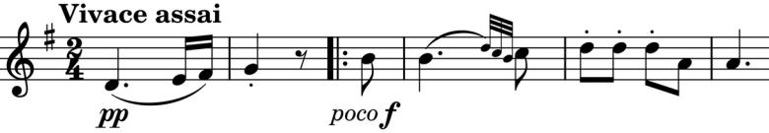

*"My end is my beginning, and my beginning my end"* . The quartet opens, completely originally, with a pianissimo 2-bar phrase

(*illustrated*). It is followed by the main theme which is derived from it and which itself ends with that same 2-bar phrase - as indeed does the whole movement, but with it repeated, just to make sure that it really is the end.

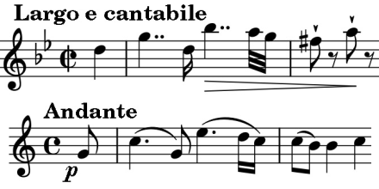

The beautiful *Largo* aria is a splendid showcase for the first violin. Its theme (*illustrated*) is clearly similar to that of the *Andante* oboe introduction to 'Che puro ciel' (*illustrated*) in Gluck's *Orfeo ed Euridice* which Haydn had conducted at Eszterháza in 1778.

The *Scherzo* starts with the rhythmic game of two against three, leading after seven bars to an unexpected silent bar followed by a version of that 2-bar opening/ending phrase, which also (naturally) ends the movement.

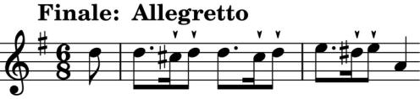

The *Allegretto Finale* (*illustrated*) is a set of variations in the style of a Siciliano leading to a final cheerful *Presto.*