**Programme notes by Chris Darwin. Please use freely for non-commercial purposes.**

**Josef Haydn (1732-1809) String Quartet in Bb Op 33 no 4 (1781)**

*Allegro moderato*

*Scherzo: Allegretto*

*Largo*

*Finale: Presto*

Famous string quartets have a problem in daring to perform this work. In his book "The Great Haydn Quartets" Hans Keller includes 44 of the 45 quartets between Op 20 and Op

1. But Op 33 no 4, uniquely, doesn't make 'greatness'. Here is Keller in typically moderate and modest mode: *"It has, unfortunately to be admitted that by playing the Bb quartet as often and as importantly as any of the other quartets from Op 33 many a famous quartet ... proves its utter ignorance and incomprehension of what matters in a great quartet and what doesn't …"* (p.7) !! So, thank you Doric for braving Keller'sposthumous scorn to bring us this delightful if uneven work.

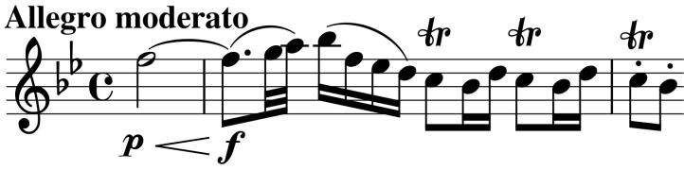

Unusually, the piece opens (illustrated) half-way through the bar before a little dotted figure that seeds many of the motifs in the quartet. The following repeated trilled figure provides material for the accompaniment in a

movement which is dominated by the first violin. The *Scherzo* second movement's theme is a simple modification of the work's opening, preparing us for the glorious slow movement – the emotional heart of the

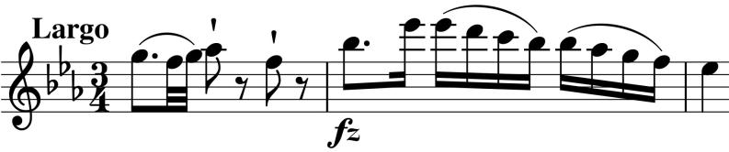

work. Its theme starts with another version of the dotted figure (illustrated) and again the first violin gets the lion's share.

The last movement's speed and wit provides a splendid contrast. Again the dotted motif shapes the theme, but this time the dotted note is replaced by three repeated notes (illustrated – under *x*). Again, the first

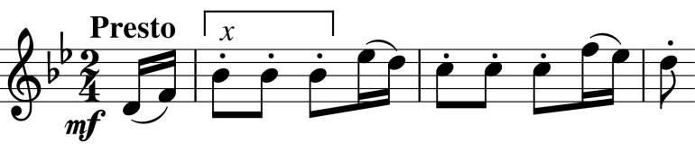

violin has most of the fun, but Haydn makes rather mean amends to the two inner parts by giving them over 60 bars of manic accompaniment shortly before the

first violin further transforms the theme with grotesque jumps and the work ends with a typical Haydn surprise.