**Programme notes by Chris Darwin: Use freely for non-commercial purposes**

**Josef Haydn (1732-1809) String Quartet in E flat Op 33 no 2 *'The Joke'* (1781)**

*Allegro moderato*

*Scherzo: Allegro*

*Largo e sostenuto*

*Finale: Presto*

In the course of the five years from 1768 to 1772, Haydn published three sets of quartets, the Op 9, 17 and 20, in which the older Divertimento form evolved into the true string quartet with free and independent parts. The exercise of manufacturing over a hundred Trios for viola, cello and Prince Esterhazy's baryton during the previous decade had schooled Haydn in writing for individual string parts without an accompanying harpsichord. This technical facility, his extraordinary structural genius, and the continued maturing of his creative powers happily came together to produce in the Op 20 quartets six works of revolutionary genius.

But then Haydn wrote no more quartets for a decade, until the Op 33 set of six in 1781. Probably all his energies were used directing the music for 50 operas (5 his own compositions) and various marionette productions at the Esterhazy palace. In 1779 the Prince engaged a lively young singer, Luigia Polzelli, with whom Haydn developed a passionate relationship. Whether she served as a stimulus or a distraction, or even both is not known, but by 1780, energy flowed back into his symphonies and Haydn started to compose string quartets again. He announced the Op 33 set to potential subscribers as "brand new à quadro ... written in a new and special way, for I have not composed any for ten years". This advert was maybe a bit of a come-on to revive the market, but the new set are altogether more relaxed and confident than the Op 20s. They have jokey scherzi rather than minuets, less "Sturm und Drang", more major than minor and a variety of different finale forms replacing Op 20's intellectual fugues.

Commissioned by the publisher Artaria, the Op 33 "Russian" quartets are dedicated to Paul, Grand Duke of Russia, son and heir to Catherine the Great. He and his musically cultured Prussian wife Maria Feodorovna visited Vienna in 1781 at the start of a 14-month tour of Europe, travelling under the pseudonym of the Count and Countess Severny. Many of these six quartets were premiered in the duchess's apartment in Vienna on Christmas Day 1781.

The Op 33 set appeared in Vienna just as the 26 year-old Mozart arrived there in pursuit of a freelance career. The 49-year-old Haydn's new quartets catalysed Mozart into taking seriously the writing of more quartets of his own, resulting in the famous set of six quartets that he dedicated to Haydn. Fortunately Haydn was not disheartened by Mozart's genius, but generously acknowledged it and in turn was prompted to more quartet invention. They played quartets together, spelling each other on violin and viola. Now *that* is where I would have liked to have been a fly on the wall !

The work opens (illustrated) in the genial, conversational mood typical of the 'new' style of the Op 33 set. This opening phrase provides all the material for the first

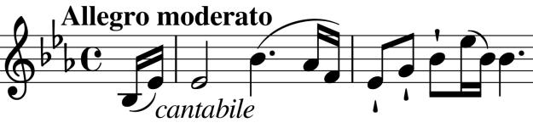

movement – Haydn's mono-thematic method of composition. Listen out particularly for the way it is tossed between the instruments at the start of the development (straight after the repeated first half of the movement).

The *Allegro Scherzo* (in contrast to earlier quartets' *Allegretto Minuet*) second movement is notable for exploiting the then common practice of *portamento* or *glissando*: sliding between one note and the next. Before the long-necked violinist Louis Spohr invented the chin-rest around 1820, it was difficult to change position on the violin and viola (particular downward), without some slide being heard. Consequently music was performed with a variety of different slides that were an intentionally integral part of the melodic line. In the *Trio* section of the *Scherzo* Haydn

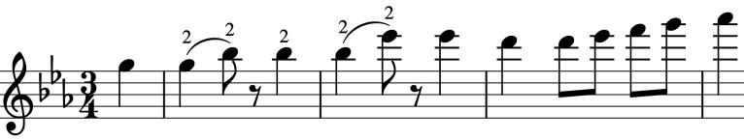

specifically marks adjacent notes to be played with the same finger, necessitating a slide (*illustrated*).

The intended rustic effect is enhanced for today's listeners by the rare use of *portamento* in playing today's chin-rested violins. Modern baroque players frequently play without chin rests and consequently use *portamento* more, or choose to change strings rather than position.

Having the *Scherzo* (or *Minuet*) second often heralds a particularly important slow movement. Such is the case here where for the first time in Haydn the viola ( *sic*) introduces the hymn-like theme, sparsely accompanied just by the cello. The two violins restate the duet with added gentle interjections from the cello. There is then an abruptly angular passage which contrasts with the increasingly complex statements of the main theme.

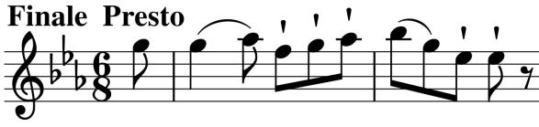

The last movement is a lively contrasting *Rondo* built on a sequence of four 2-bar phrases (*first one illustrated*). The quartet's solely English nick-name "The Joke" was a late addition and refers

to the last movement's ... No I couldn't possibly spoil it for you. But don't let my hesitancy inhibit your applause - you can even join Clara Schumann in laughing out loud. As Mary Queen of Scots and T.S. Eliot both wrote "In my end is my beginning".