Programme Note by Chris Darwin: please use freely for non-commercial purposes

**Josef Haydn (1732-1809) String Quartet in B minor Op 33 no 1 (1781)**

*Allegro moderato*

*Scherzo: Allegro di molto*

*Andante*

*Finale: Presto*

In the course of the five years from 1768 to 1772, Haydn published three sets of quartets, the Op 9, 17 and 20, in which the older Divertimento form evolved into the true string quartet with free and independent parts. The exercise of manufacturing over a hundred Trios for viola, cello and Prince Esterhazy's baryton during the previous decade had schooled Haydn in writing for individual string parts without an accompanying harpsichord. This technical facility, his extraordinary structural genius, and the continued maturing of his creative powers happily came together to produce in the Op 20 quartets six works of revolutionary genius. But then Haydn wrote no more quartets for a decade, until the Op 33 set of six in 1781. Probably all his energies were used directing the music for 50 operas (5 his own compositions) and various marionette productions at the Esterhazy palace. In 1779 the Prince engaged a lively young singer, Luigia Polzelli, with whom Haydn developed a passionate relationship. Whether she served as a stimulus or a distraction, or even both is not known, but by 1780, energy flowed back into his symphonies and Haydn started to compose string quartets again.

He announced the Op 33 set to potential subscribers as "brand new *à quadro* ... written in a new and special way, for I have not composed any for ten years". This advert was maybe a bit of a come-on to revive the market, but the new set are altogether more relaxed and confident than the Op 20s. They have jokey scherzi rather than minuets, less "Sturm und Drang", more major than minor and a variety of different finale forms replacing Op 20's intellectual fugues. The Op 33 set appeared in Vienna just as the 26 year-old Mozart arrived there in pursuit of a freelance career. Haydn's new quartets catalysed Mozart into writing more quartets of his own, resulting in the famous set of six quartets that he dedicated to Haydn.

Haydn's B minor quartet is the most intense of the six Op 33 and the only one in a minor key. The *Allegro moderato* is one of Haydn's

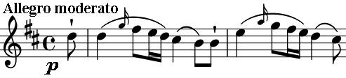

mono-thematic movements with the opening phrase providing much of the material. Though restricted, the material allows Haydn to lead us

off in different tonal directions before settling on the home key of B minor. Where the contrasting second subject should occur, we get the same theme but now in D major. The lack of a contrasting second subject requires Haydn to be especially inventive in the second half of the movement.

The S*cherzo* second movement is a faster, forward-driving *Minuet* rather than the very fast, one-in-a-bar type of *Scherzo* that came later. The seventh bar contains an example of *bariolage* (variegated) bowing

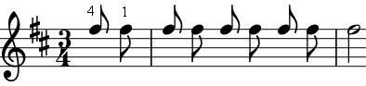

where the same note is alternated across adjacent strings. Haydn uses this technique extensively in a later quartet (op 50 no 6) leading to the nickname 'The Frog'. The *Presto* finale requires great dexterity from the upper strings with rapid arpeggios and more bariolage-like string crossings. The movement is in serious, sonata form and shows that the now almost 50-year old composer has significant alternatives for his last movements to the fugues of his Op 20 quartets.