Programme notes by Chris Darwin. Use freely for non-commercial purposes

**Josef Haydn (1732-1809) String Quartet Op. 20 No. 4 (1772)**

*Allegro di molto*

*Un poco adagio e affettuoso (Theme with 4 variations)*

*Minuet. Allegretto alla zingarese - Trio*

*Presto e scherzando*

Writing in four parts had been recognised both in theory and practice as the bedrock of string music long before the 1750s when Haydn started to compose string quartets. But four-part string music then had a variety of forms, none of which we would recognise as a 'string quartet' and was predominantly based on a basso continuo cello with optional keyboard, or was a light keyboard-less divertimento.

The 18-year-old Haydn got into writing for a quartet of strings thanks to one Baron Fürnberg, who asked him to write something to be played at his place at Weinzierl in the Wachau valley. The four musicians were the local pastor, his estate manager, Haydn and the cellist brother of the Johann Albrechtsberger who later taught Beethoven composition. The resulting Op 1 & 2 quartets were still, both in name and form, divertimenti.

For the next 10 years Haydn wrote no quartets, his energies went into composing for and conducting Prince Nicholas Esterházy's weekly orchestral concerts, and in composing scores and scores of trios for the prince's baryton (a sort of viola da gamba) with viola and cello. But then, in the five years running up to his 40th birthday, in an extraordinary burst of creativity, Haydn invented the string quartet. His baryton trio experience had no doubt given him facility in small ensemble part-writing. He could therefore express new musical ideas in structures that gave equal contrapuntal weight to the four parts.

In those five years he wrote three sets of six quartets, Op 9, Op 17 and the crucial Op 20. Op 9 are still in name divertimenti, but the form has changed, dropping the second Minuet to give just four movements and expanding the previously lightweight finale with contrapuntal substance. In Op 17 the movements become more thematically united, and the cello enjoys increased freedom. Finally, in Op 20, the cello is fully liberated, and Haydn has found the form for six distinctive masterpieces. These quartets herald the arrival of the 'classical' style, moving decisively away from the baroque. One of the main elements of this new style is the 'short articulated phrase' (Charles Rosen) as against the flowing continuity of the baroque. Tonight's D major quartet provides a striking example.

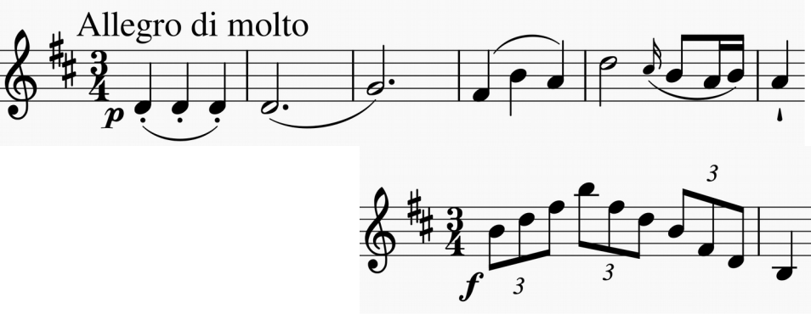

It opens with seven completely independent 6-bar phrases. The first five phrases are variants of the opening one with its gently

repeated crotchets and rising fourth (illustrated). The last two introduce a bold triplet arpeggio (illustrated) and these two contrasting ideas provide the material for the whole movement.

The second movement, also starting with a rising fourth, equitably gives all the instruments a turn in presenting variants of the poignant D minor theme. The

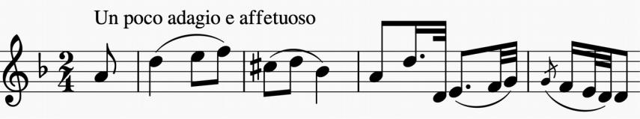

opening of the following gypsy style Menuet (now back in D major) is also closely derived from the variations' theme (rising fourth again). The gypsy feel continues into the energetic last movement with its opportunities for boisterous ricochet bowing. Its second half starts with a contrasting *cantabile* theme, harking back to the poignant mood of the work's opening before provoking lively counterpoint. The fun finally subsides in contented exhaustion.