Programme Note by Chris Darwin: please use freely for non-commercial purposes

**Josef Haydn (1732-1809) String Quartet Op. 20 No. 2 in C (1772)**

*Moderato*

*Capriccio: Adagio*

*Menuet: Allegretto*

*Fuga a quattro soggetti: Allegro*

Writing in four parts had been recognised both in theory and practice as the bedrock of string music long before the 1750s when Haydn started to compose string quartets. But four-part string music then had a variety of forms, none of which we would recognise as a 'string quartet' and was predominantly based on a *basso continuo* cello with optional keyboard, or was a light keyboardless *divertimento*. The 18-year-old Haydn got into writing for a quartet of strings thanks to one Baron Fürnberg, who asked him to write something to be played at his place at Weinzierl in the Wachau valley. The four musicians were the local pastor, his estate manager, Haydn and the cellist brother of the Johann Albrechtsberger who later taught Beethoven composition. The resulting Op 1 & 2 quartets were still, both in name and form, *divertimenti*.

For the next 10 years Haydn wrote no quartets, his energies went into composing for and conducting Prince Nicholas Esterházy's weekly orchestral concerts, and in composing scores and scores of trios for the prince's baryton (a sort of viola da gamba) with viola and cello. But then, in the five years running up to his 40th birthday, in an extraordinary burst of creativity, Haydn invented the string quartet. His baryton trio experience had no doubt given him facility in small ensemble part-writing. He could therefore express new musical ideas in structures that gave equal contrapuntal weight to the four parts. In those five years he wrote three sets of six quartets, Op 9, Op 17 and the crucial Op 20. Op 9 are still in name *divertimenti*, but the form has changed, dropping the second Minuet to give just four movements and expanding the previously lightweight finale with contrapuntal substance. In Op 17 the movements become more thematically united, and the cello enjoys increased freedom. Finally, in Op 20, the cello is fully liberated, and Haydn has found the form for six distinctive masterpieces.

The newly liberated cello opens the C major quartet singing above both the viola's base line and the second violin's close

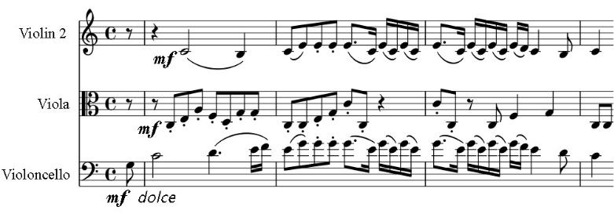

harmony. At the start of the devel-opment, the second violin and viola drive a relentless accompaniment while the first violin and cello lead each other astray into remote keys with a motif derived from the open-ing bar. Then even the viola gets

to soar, cello-like with the opening theme. Four truly equal partners.

The equality of the partners is also apparent in the opening of the darkly intense *Adagio*: four bars of unison followed by the cello restating the theme to the accompaniment of the upper strings. Although the first violin subsequently gets most of the decorative passagework, it is frequently joined by the three others to give a rich texture. The viola is given a complex triplet semiquaver accompaniment to the first violin's soaring *cantabile* second theme, then the second violin takes the theme while the first takes over the triplet accompaniment.

The *Minuet* contrasts the drone of a syncopated and then chromatically drooping bagpipe with the call of a chirpy bird, while in the *Trio* the cello (again) sings out a theme derived from the droop.

The last movement is a contrapuntal *tour de force*: a four-part fugue with four themes, played *sotto voce* until a *forte* outburst shortly before the end.

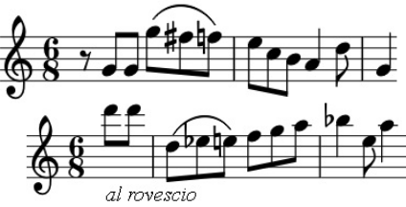

Just over half-way through Haydn writes *al rovescio* as he in-verts the fugal subject. In the autograph edition at the *forte* outburst, Haydn wrote "*Laus. Omnip. Deo. Sic fugit amicus amicum*" (Praise the Lord. Thus one friend flees another friend). Haydn has clearly established his contrapuntal credentials with

both this fugue and the last-movement fugues of two other of the Op 20 quartets. But he only writes one more in all of his subsequent 40 or so quartets – his contrapuntal tech-nique is now firmly integrated into his quartet writing.