**Programme notes by Chris Darwin – use freely for non-profit activities**

**Josef Haydn(1732-1809) String Quartet in Bb Op.1 No.1 Hob III:1 'La Chasse' (1750)** *Presto*

*Minuet primo & secondo*

*Adagio*

*Minuet & Trio*

*Finale: Presto*

Writing in four parts had been recognised both in theory and practice as the bedrock of string music long before the 1750s when Haydn started to compose string quartets. But four-part string music then had a variety of forms, none of which we would recognise as a 'string quartet' and was predominantly based on a *basso continuo* cello with optional keyboard, or was a light keyboardless *divertimento*.

At 18, Haydn had little formal musical education: he had learned the violin and had been a chorister in Vienna's St Stephen's Cathedral for 10 years but in music theory and composition was self taught from choirmaster Fux's textbook '*Gradus ad Parnassum*'. The cathedral choir's repertoire would have been based on the Italian tradition from Palestrina onwards, but would have had little if any Bach (tucked away in provincial Lutheran Leipzig) or Handel (living-it up in London).

Haydn got into writing for a quartet of strings thanks to one Baron Fürnberg, who asked him to write something to be played at his home at Weinzierl in the Wachau valley. The four musicians were the local pastor, his estate manager, Haydn and the cellist brother of the Johann Albrechtsberger who later taught Beethoven composition. The resulting Op 1 & 2 quartets were still, both in name and form, *divertimenti a quattro*, with five movements arranged as a bridge structure ABCBA .

The middle movement, a concertante-style *Adagio,* is the most substantial. After a chorale-like introduction, the violin presents and then decorates a beautiful *cantabile* melodic line which perhaps Mozart had in mind when he wrote

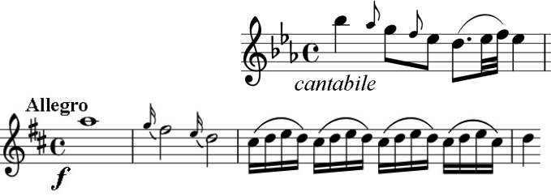

the opening Allegro of his well-known D major Divertimento, 20 or so years later.