**Josef Haydn (1732 – 1809) String Quartet Op.71 No.3 in E flat major (1793)**

*Vivace*

*Andante con moto*

*Menuet & Trio*

*Finale – Vivace*

Haydn’s six “Apponyi” quartets (Ops 71 and 74) were written in 1792 & 1793 between his two extended visits to London. Prince Nicholas Esterházy, Haydn’s patron, to whom he was devoted, had died in the autumn of 1790; his successor, Prince Anton, did not care for music and disbanded the Esterházy orchestra, for whom Haydn had composed for the previous 30 or so years, but kept Haydn on full pay with only nominal duties. Haydn was thus free to apply for leave to accept Johann Peter Salomon’s offer to spend a year in London (against Mozart’s advice, who thought the 58 year-old master too old for such jaunts). Its crowded, vibrant musical scene challenged and exhilarated Haydn, and his six new “London” symphonies, written for a larger orchestra, hall and audience than at Esterházy, were a sensation. Haydn returned home in the summer of 1792, to a Vienna without Mozart, who had died in December just short of his 36th birthday.

The eponymous Apponyi, Count Anton Georg, was a relative of the Esterházys, and paid Haydn 100 ducats for the privilege of having the six quartets publicly dedicated to him. The quartets of the set have a power and brilliance that reflects Haydn’s experience with the London orchestras and his intention to take the quartets back to London on his return. But, as Rosemary Hughes points out, today’s quartet Op 71 no 3 also shows the opposite tendency; Haydn withdraws and turns his gaze inward with a spareness of line and an economy of thematic material that foreshadows his later style. Paradoxically, at first glance the opening is far from inward looking: a bold E*b* major chord, designed perhaps to silence the large London audience? But

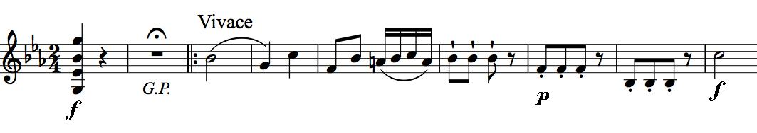

the opening two bars are more than that. First, the chord firmly establishes the home key, so that Haydn can rapidly move to the dominant key of B*b,* and second, the General Pause presages the two bars of “off-stage” *piano* that echo the three repeated quavers of the last bar of the four-bar theme. These two *piano* bars form a sort of filled two-bar pause. The four-bar theme itself provides all the raw material for

the movement – a miracle of intense terseness. Listen out in the development for the three-quaver figure popping up everywhere.

The second movement, a lively Andante, consists of variations interspersed with its recurring theme. The theme starts:

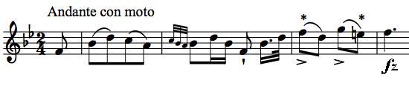

In the third bar, the second violin plays crotchet F and E an octave below the (*)

quavers of the first violin, and Haydn adds a curious marking – “*licenza*”. Hans Keller suggests that an appropriate translation is “I know!”. (i.e. *I know that I’m failing my Quartet Composition exam by writing parallel octaves, but hey, it sounds good – and I bet Brahms and Schönberg will do it too!*). The viola takes the themeinto the minor for the dark first variation, the theme is reprised and then the violin dances off in triplet semiquavers for the second variation. Now comes the darkest episode of the whole quartet, as the cello takes the minor theme accompanied by the other instruments at the bottom of their registers. But then a typical Haydn masterstroke: the cello drops out and the upper strings twitter away *very staccato and pianissimo* at the tops of their registers like a charm of goldfinches. The themereturns again, and now another Haydn surprise: the music stops, but doesn’t end! After more than a bar of silence, the theme starts again, and its last phrase is echoed back by the cello. Didn’t something like this happen at the beginning of the first movement? The theme is taken up again, another phrase - this time of two bars - is echoed, and two *forte* chords end the movement.

The third movement is a Minuet and Trio with the Trio using a group of semiquavers that is an inversion of that in the first movement’s theme illustrated above. The Finale is another monothematic movement based on a folksy tune with an um-pa-pa accompaniment. Haydn works his magic on this simple material, weaving decorative semiquavers round it and making contrapuntal hay. A few lines before the end Haydn pulls the pause and echo trick again, before the first violin races for the finishing post.