**Josef Haydn (1732 – 1809) String Quartet Op 64 No 6 in E flat major (1790)**

*Allegro*

*Andante*

*Menuet & Trio: Allegretto*

*Finale: Presto*

This quartet is the last of Haydn's 12 “Tost” quartets. From 1783 to 1788 the Hungarian Johann Tost was principal second violin in the Esterházy orchestra of which Haydn was music director. When Tost left Esterházy in 1788 to freelance in Paris, Haydn entrusted 6 quartets to him with a view to finding a publisher. Tost was successful, and they were published in Paris in two sets of three as Op 54 and 55. A later set of six, Op 64, were written in 1790, the year that Haydn first visited London. Around this time Tost returned from Paris, married the housekeeper at Esterházy (of whom Haydn was also fond) and used her money to set up a successful cloth business in Vienna. There in 1791 he also found a publisher for this Op 64 set, which are gratefully dedicated to him. Tost continued to play the violin and commission chamber works, whose performances in aristocratic homes provided an entrée for his cloth business; incidentally he is possibly the dedicatee (*"composto per un amatore ongarese")* of the last two of Mozart's string quintets.

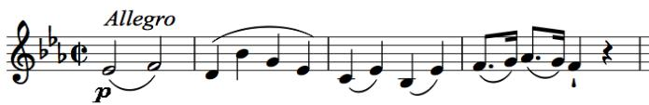

The *Allegro* is one of Haydn's mono-thematic movements, based on the quiet, thoughtful opening. As the music

develops, the parts twine around each other, until after a general pause the theme appears in spiky syncopation tossed between the instruments.

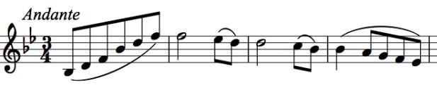

The *Andante* is a tantrum sandwich. At the start, all is well with the world: *“the melodic lines serenely curving and intersecting in*

*tender dissonances”* (Rosemary Hughes). Suddenly the first violin tosses his toys out of the pram for 15 bars

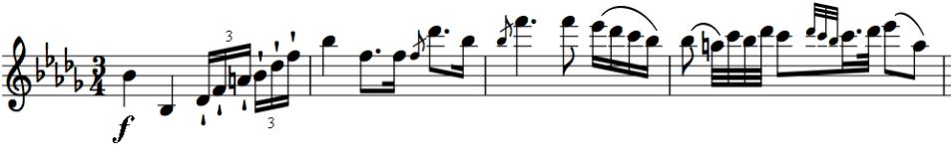

of B-flat minor tantrum. But serenity returns, as if nothing had happened.

Haydn's original Trio for the third movement ends with the first violin stepping up to a rare top Eb, but later editions include an additional easier version. The finale is an energetic romp, playing rhythmic tricks typical of Haydn. He repeatedly and unpredictably stops the music, eventually restarting it at half speed before racing to the end.