Programme Note by Chris Darwin: please use freely for non-commercial purposes

**Josef Haydn (1732-1809) String Quartet in C op. 54 No. 2 (1788)**

*Vivace*

*Adagio*

*Menuetto – Trio*

*Finale: Adagio – Presto – Adagio*

The three Op 54 quartets are the first of the 12 quartets that Haydn wrote for the Hungarian violinist Johann Tost (we heard a quartet from a later group – Op 64 no 6 - played by the Castalian Quartet at last year's launch concert). From 1783 to 1788 Tost played in the Esterházy orchestra of which Haydn was music director. When Tost left Esterházy in 1788 to freelance in Paris, Haydn entrusted 6 quartets to him with a view to finding a publisher. Tost was successful, and they were published in Paris as Op 54 & 55. This C major quartet is a masterpiece, the best of the bunch, profound and original, producing fire and eloquence from Tost's Hungarian-flavoured virtuosity. The opening 6 bars set the scene with

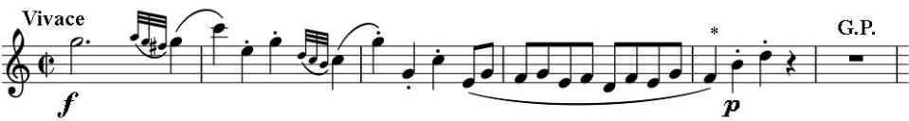

a bold statement, but where a lesser composer might have

ended the opening phrase on the F at the beginning of bar 5 (*), Haydn adds, *piano*, an interrogatory two notes: “Really?”. There is a reflective pause, followed by a repeat of the statement and question before Haydn shifts into a remote key and we stride off into the rest of the movement.

This questioning forms the heart of the extraordinary slow movement. It starts with a solemn chorale-like

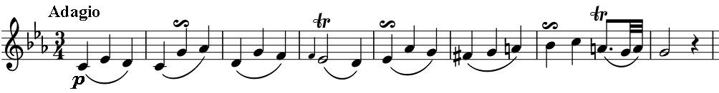

8-bar phrase in the lower three parts. The motif repeats almost unchanged

whilst Tost's Hungarian violin weaves a searching, improvisatory magic. The uncertainty is unresolved, with the violin inserting anguished discords just before the end.

The mood lightens in the directly following *Menuetto*, which just before its end echoes the “Really?” motif, this time in rising chromatic

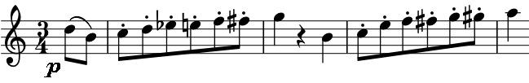

quavers. The doubts are roundly dismissed but immediately reappear more forcefully in the minor key *Trio*, again with jabbing

anguished discords. The *Finale* is one of Haydn's most original: a long *Adagio*, interrupted by a short, skittish *Presto*, and ending with more of the *Adagio*. The rising question opens the movement, but after a few bars consideration, Haydn gives us one of his most sublime passages: the cello plays simple, long, slow, rising arpeggios while the violin weaves a very different magic from that of the slow movement, resolving all doubts. The brilliant *Presto* acts as a comic foil, but the returning *Adagio* restores calm content.