**John Hawkins (b.1949) Fuzon (2012)**

John Hawkins studied composition with Malcolm Williamson and Elisabeth Lutyens. While continuing to write music, he worked for many years at the book publisher Thames and Hudson. BBC broadcasts include his ‘Sea Symphony’, ‘This World’ for choir and two trumpets and ‘Variations’ for piano. The many pieces stimulated by William Blake’s writing include tonight’s quartet ‘Fuzon’; ‘Urizen’ for viola and piano; ‘This World’; and the song cycle ‘Portions of Eternity’.

The CD of music for clarinet ‘Simplicius’ (Claudio Records 2020) includes a complete setting of Edward Lear’s ‘The Dong with a Luminous Nose’ for voice with solo clarinet: with the addition of a dancer it was performed this year, as part of the Tête à Tête Opera season. An event devoted to the WWI poet Edward Thomas was performed in 2022 in Steep where he lived before going to fight in France. It included the song cycles ‘The Unknown Bird’ and ‘Strange Bridge’. ‘Another Orpheus’ for string orchestra will be performed by the Stane Street Sinfonietta this November in its series dedicated to the poet Shelley.

‘Fuzon’ is based on William Blake’s eponymous figure. In Blake’s poems and illuminated books Urizen represents the sterile uncreative figure but Urizen has a son Fuzon – the embodiment of fire who, 'On spike flames rose, his hot visage flam'd furious!'

‘Fuzon’ was first performed by the Piatti Quartet in 2012: they have since played it many times (one of their performances can be heard on YouTube). The short single movement opens with slow repeated

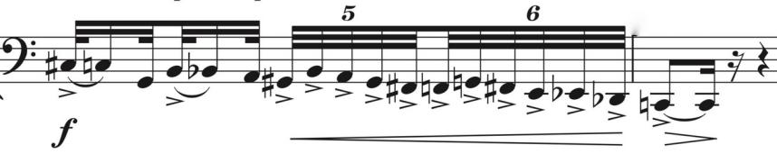

notes and chromatic phrases interrupted by dramatic outbursts (*illustrated*).

Repeated notes, fast and slow, figure throughout the quartet while the lyrical phrases are transformed into a

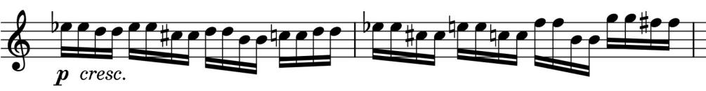

virtuosic presto (*illustrated*).

The quartet ends with eerie pizzicato glissandi on the ’cello while the 1st violin continues with slowly vanishing repeated notes.