Programme notes by Chris Darwin. Please use freely for non-profit activities.

**Henryk Górecki (1933-2010) String Quartet No 1 Op 62, ‘*Already It Is Dusk*’ (1988)**

Henryk Górecki is best known for his 1976 Third Symphony (“Symphony of Sorrowful Songs”), whose recording, made fifteen years later by Dawn Upshaw with the London SInfonietta, sold more than a million copies worldwide. The simplicity of this symphony with its slow-moving modal harmonies and persistent repetition was the result of a radical stylistic move by Górecki. In the '50s and '60s, he had been at the forefront of the Polish *avant garde,* using serialist techniques and rubbing shoulders with Boulez andStockhausen. As a result of the move, he was rejected by the modernists: his "*new material was no longer cerebral and sparse; rather, it was intensely expressive, persistently rhythmic and often richly coloured in the darkest of orchestral hues*". This stylistic move was roughly contemporary with the rise of minimalism in the US and the advent of the so-called “mystic minimalists” Alan Hovhaness, Arvo Pärt and John Tavener.

Throughout the '70s and '80s Górecki was preoccupied with choral and sacred music, but his interest in chamber music was rekindled in the early '80s by a commission to write a piano trio. There followed a commission from the Kronos Quartet for his first string quartet which we are hearing today. The Kronos subsequently commissioned two more quartets.

The work runs continuously as a single movement for about 15 minutes. Its title and main theme derive from a motet '*A prayer for children going to sleep'* by the 16th century Polish Renaissance poet and composer Wac!aw z Szamotu!:

*Already dusk is falling, night closes in, / Let us beseech the Lord for help, / To be our guardian, / To protect us from wicked devils, / Who especially under cover of darkness / Profit from their cunning.*

After an attention -gathering opening chord of a bare fifth, the motet's theme is heard in the viola preceded in canon

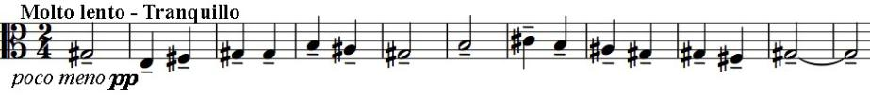

with transformed versions of itself on the other instruments.

These transformations (upside-down, backwards etc) are tricks of Górecki's erstwhile twelve -tone trade. The bare fifths return but now in a fortissimo strident rhythm, followed in turn by an extended version of the canon. These two ideas alternate throughout the introduction, each becoming more extreme. The main section develops a folk theme with energetic duetting between the paired violins and the viola plus cello, leading to a homophonic passage lacking any melody to be played '*tempestuously and with maximum passion and expression*', culminating in the opening bare fifth. A reminder of the initial canonic theme and finally a sequence of simple major triads (marked ARMONIA) end the work.