**Programme notes by Chris Darwin. Use freely for non-commercial purposes**

**Gabriel Fauré (1845 - 1924) Piano Quartet No 1 in C minor, Op.15 (1876–79, rev 1883)**

Allegro molto moderato

Scherzo: Allegro vivo

Adagio

*Allegro molto*

Stephen Johnson has recorded an enlightening Radio 3 Discovering Music programme on this work to which I am indebted: <https://www.bbc.co.uk/programmes/b01s35qv>

Although Fauré is best known by most people for his vocal writing, in particular his songs and Requiem, some of his best work is the chamber music that he wrote throughout his life: two sonatas each for violin and cello with piano, a piano trio, a string quartet, two piano quartets and two piano quintets.

Fauré's career was not straightforward. Born to a family of minor aristocrats in southern France, he was sent aged 9 to board at Niedermeyer's music school in Paris, which trained organists and choirmasters. Fortunately, the excellent grounding it gave to Fauré in renaissance church music was extended to include Schumann, Liszt and Wagner when, on Niedermeyer's death in 1861, Saint-Saëns took over the piano and composition classes. But Fauré remained attached to the modal harmonies of early music throughout his life, much of which was spent as an organist or choirmaster.

His attempts to secure a post at the Paris conservatoire were for a long time thwarted by conservatives who despised his ecclesiastical background and disliked his style of composition. However, he eventually secured a post there aged 52 and, surprisingly, 8 years later, the subversive Fauré became the conservatoire's director. He amply justified his enemies' fears by instituting (necessary) radical reforms, earning himself the sobriquet 'Robespierre' ! While at the conservatoire he taught Maurice Ravel, Georges Enescu and Nadia Boulanger. Deafness, elevation to the Légion d'Honneur and gentle hints eventually prised him from the directorship into retirement in 1920 at the age of 75.

His first piano quartet was started in 1876 during a particularly emotional time for Fauré́. In July 1874 he became engaged to Marianne Viardot with whom he had been in love for five years, ever since Saint-Saens had introduced him into Marianne mother's salon. But his intense feelings for her were not reciprocated – she evidently felt a mixture of affection and fear towards him – and by October she had broken off the engagement.

The intensity of his feelings at this rejection is shown most clearly in the slow third movement of the piano quartet. The strings gradually build a rising theme which

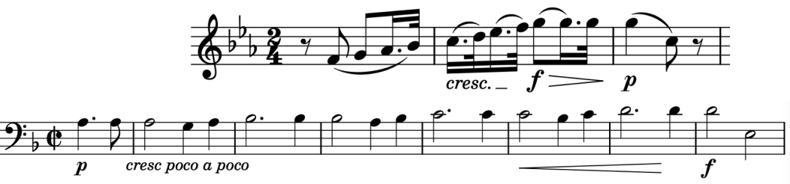

ends in a poignantly falling fifth (*illustrated* ). As Stephen Johnson

points out this bears more than a passing resemblance to the baritone solo at the beginning of the *Libera Me* of Fauré́'s Requiem (*Quando caeli movendi sunt et terra*), which he had started to compose at that time (*illustrated*). Fauré́'s world had indeed been thoroughly shaken by Marianne's rejection.

The wider musical world was also undergoing upheavals at that time: 1876 saw the first complete performance of Wagner's Ring. Although Fauré́ admired Wagner, he was quite capable of gently mocking him and remained true to his own ideals, modestly expressed, of balance and clarity.

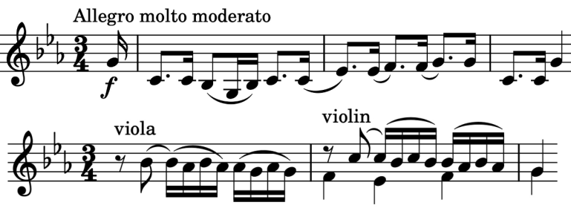

The boldly assertive opening C-minor

theme of the work, with unison

strings (*illustrated*), soon gives way

to a more gentle, lyrical conversation

led by the viola, answered by the

violin (*illustrated*). The movement

enjoys a well-structured, civilised

discussion of these ideas, with the

opening theme finally moving gently into the

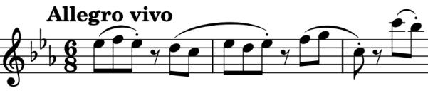

major.

The *Scherzo* contrasts two subtly different rhythms: the first given by the piano ( *illustrated*) and the second more relaxed one by the strings (*illustrated*). Its Trio section gently mutes the strings against the piano's cascading triplet accompaniment.

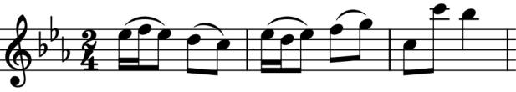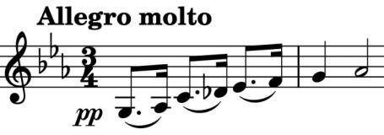

The beautiful, substantial *Adagio* which we have already mentioned leads to the exhilarating *Allegro molto* finale. Its opening (*illustrated*) is a much speeded-up version of the slow movement's rising them, integrating it with the onward drive of the first movement's opening. It contrasts gloriously with another slower rising theme

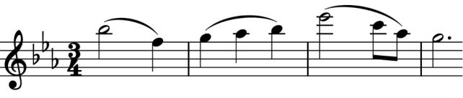

(*illustrated*) – one that you can go home singing happily!