**Antonín Dvořák (1841–1904) Piano Trio No. 3 in F minor Op. 65 (1883)** *Allegro, ma non troppo*

*Allegretto grazioso – meno mosso*

*Poco Adagio*

*Finale. Allegro con brio*

This piano trio dates from a similar time in Dvořák's life to the Op 61 quartet played by the Castalian at the beginning of the season. Prior to this time, Dvořák's music was Slavonic, folk-oriented, generally genial and carefree. But, as a result of an anti-Czech political mood in Austria, his Viennese audience had become *“prejudiced against a composition with a Slav flavour”* ( Dvořák to the conductor Richter, 1884). His new style, apparent both here and in the Seventh Symphony Op 70, was altogether darker and more dramatic. Another likely influence on this piano trio was the recent death of his mother. Whatever its background, the work was complex and masterful, full of intense contrasts - his finest chamber work yet.

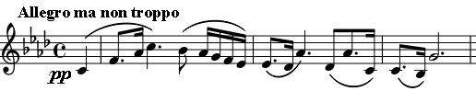

The first movement starts innocuously enough with the violin and cello very quietly in octaves. But two bars later they

descend fortissimo from the heights in triplets into angry despair with spread chords. The cello then introduces a quiet, tender theme, and the movement continues on an elegiac, emotional roller coaster with a wealth of contrasting melodic material. The writing is complex, reminiscent of Schumann and of Dvořák's champion, Brahms.

The scherzo-like *Allegretto* shifts the key down a third from the previous F minor into C# minor – actually D*b* minor in disguise, but Dvořák kindly gives the player only 4 sharps instead of 8 flats! Why does Dvořák write in these complicated keys? You'd never catch Mozart doing that. (Ironically, in the 1930's a distant American relation, August Dvorak, designed a simpler keyboard for the typewriter!) The movement starts off with the strings alternating notes that can sound like paired quavers in a fast conventional scherzo in 3/4, but are actually triplets in a slower 2/4, a time signature that is confirmed when the piano enters in the third bar. Playing 3 against 2 in interesting ways was a favourite device of Dvořák's champion, Brahms, and indeed this work has been described as Dvořák's most Brahmsian. The slower trio is in D*b* major (only 5 flats!).

The *Poco Adagio* is a masterpiece, if anything could have won the Viennese audience over to a Czech composer, this

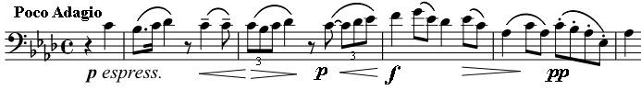

would have done it. The cello introduces a melancholy, minor key theme and then joins the

violin's embellished reiteration. Now comes a stroke of genius: the violin, unaccompanied, plays the tenderest of figures in the major that becomes a little canon with the cello. In turn, the cello

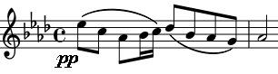

leads, again embellishing, and the violin follows. Soon demisemiquaver rumblings in the piano presage a stormy passage (in 5 sharps, aka 7 flats), before the violin soars away *pianissimo* to a top B (aka C*b)* and calm returns. All these glories are revisited before the movement ends happily.

The *Finale* is based on the Czech Furiant dance – in 3/4 time with marked cross-rhythms, the loud, energetic opening contrasting with a lilting

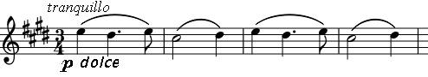

waltz-like episode introduced by the violin and cello.

Towards the end, themes from the previous movement are recalled and the music pauses before the final 8-bar dash.