**Programme notes by Chris Darwin. Use freely for non-commercial purposes Antonín Dvořák (1841 – 1904) Piano Quintet in A Major Op 81 (1887)**

1. *Allegro, ma non tanto*
2. *Dumka: Andante con moto; Vivace*
3. *Scherzo (Furiant): Molto vivace*
4. *Finale: Allegro*

This work is actually Dvořák's second Piano Quintet in A major. He became dissatisfied with the first (an early work Op 5 composed in 1872) shortly after its premier and destroyed the score. Fifteen years later, he had second thoughts and extensively revised a friend's copy. After third thoughts, he decided to write a completely new piece: today's Op 81 and one of his most popular. In it he reverts to composing in his earlier Bohemian folk idiom, although Brahms had urged him to adopt a more Germanic style.

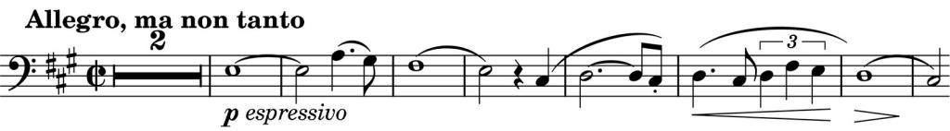

The radiant, lyrical opening theme on the cello (*illustrated*) is answered by an

energetic figure from the violin, which then becomes more assertively double-dotted (*illustrated*). A wealth of similarly contrasting

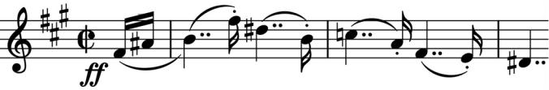

material pours into the mix as Dvořák stirs the pot with skilful glee.

A *Dumka* comes next. The word is from a slavic root meaning to ponder or meditate and although the sung form dates back to the 16th century the instrumental form only burgeoned in the late 19th and was particularly favoured by Dvořák. Its basis is a plaintive, strophic lament, whose slow sections can be interspersed with contrasting, faster episodes.

After a brief introduction, the viola (Dvořák's own instrument) gets the gloomy tune (*illustrated*). The overall pattern of the movement is A-B-A-C-A-B-A with A the

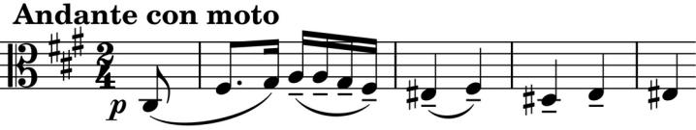

opening gloom and its derivatives, and B & C faster sections.

The *Scherzo,* subtitled *Furiant,* cracks along testing the nimbleness of the players but with the cello blessed with another theme reminiscent of the work's opening. The *Trio* gives us a tranquil respite before the returning *Furiant* dashes to the finish.

The *Finale* continues the energy of the *Scherzo* with another finger-twisting tune, which,

unfortunately for the

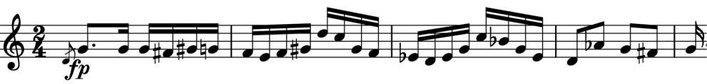

second violin

(*illustrated*), Dvořák turns into a rather ungratifying

fugue – perhaps feeling the need to acknowledge the Germanic tendency. Fugue over, the fun of Bohemian folk carries us to a rousing conclusion.