**Programme notes by Chris Darwin – use freely for non-commercial purposes**

**Antonín Dvořák (1841-1904) String Quartet No. 9 in D minor, Op. 34 (1877; rev. c.1879)**

*Allegro*

*Alla polka. Allegreto scherzando*

*Adagio*

*Poco Allegro*

1877 was an important year for Dvořák – his career took off. His compositional style had been based on the German romantics such as Mendelssohn and Schumann, and then Wagner. In 1871 he was working on an opera ‘*King and Charcoal Burner*’ which a Prague theatre promised to produce. However when rehearsals began two years later it rapidly became clear that the work was so influenced by Wagnerian principles as to make almost insuperable demands of the Prague singers and players alike. The production was cancelled. Dvorak took this rejection seriously, destroying many works from his 'mad period'. He moved his style away from contemporary German to a simpler, classical one which importantly incorporated Slavonic folk music. He completely rewrote ‘*King and Charcoal Burner*’ in 'national rather than Wagnerian' style and it was very successfullypremiered in November 1874.

To supplement his meager income from teaching, in 1874 Dvořák successfully submitted works for an Austrian National Stipendium. In 1877 a subsequent application was reviewed by a committee that now included Brahms who was eight years older than Dvořák and well-established. Brahms was so impressed by one of Dvořák's submissions

– *10 Moravian Duets for 2 sopranos and piano* - that he wrote to his publisher Simrock urging him to publish the Duets along with more of Dvořák's work ('He is a very talented man. Moreover he is poor!'). Brahms' and Simrock's support transformed Dvořák's career. Almost overnight he became famous – and richer. In gratitude to Brahms, Dvořák dedicated his Op 34 D minor quartet to him. Brahms pointed out some minor errors in the score, which Dvořák appropriately revised.

The nationalistic Czech folk style, elements of which Dvořák learned from Smetana and friends such as Janáček, contains for example: pentatonic phrases, a sharpened fourth in the minor, strong syncopation and often an absence of an upbeat to a melody, reflecting the Czech language's stress on a word's first syllable.

Curiously, four years later Dvořák returned to a less nationalistic style as a result of a commission from the Vienna-based Hellmesberger Quartet – Czech nationalism was now not welcome in Vienna either politically or musically.

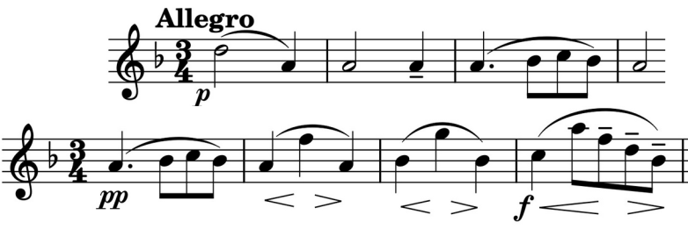

Dvořák's D minor quartet opens with a bare skeleton of a theme based on just two notes – D and A with a decorative turn in bar 3 (*illustrated*) setting a wistful tone

which is largely maintained throughout the work. This skeleton is then fleshed out leading to a new

theme, based on the turn (*illustrated*), which plays a major role in the extensive elaborations and decorations of the movement.

The second movement is a Polka with an unusual questioning coda to its Scherzo section. Next is a substantial, lyrical *Adagio* which oscillates between D major and B minor and whose bare opening recalls the start of the first movement. The strongly rhythmic final movement resists the temptation to convincingly lighten the mood, staying in D minor with only a brief venture into D major.