**Programme Notes by Chris Darwin. Use freely for non-commercial purposes.**

**Antonín Dvořák (1841–1904) Piano Trio No 4 in E Minor, Op 90, B 166 ‘Dumky' (1891)**

*Lento maestoso - Allegro quasi doppio movimento - Lento maestoso - Allegro Poco Adagio - Vivace non troppo - Poco Adagio - Vivace*

*Andante - Vivace non troppo - Andante*

*Andante moderato (quasi tempo di Marcia)- Allegretto scherzando - Meno mosso Allegro - Meno mosso, quasi tempo primo Lento maestoso - Vivace - Lento - Vivace*

The 'Dumky' Trio was written at a time when Dvořák was riding high. Thanks partly to early endorsement of his *Slavonic Dances* by Brahms, and later to the immense success of his numerous visits to England, by 1891 Dvořák was enjoying international recognition. Significantly, because of political antagonism to Czech nationalism, this success included Germany and Austria. Dvořák no longer felt obliged to compose in a Germanic style in order to appeal to Viennese audiences as he had done 10 years earlier, for example in his Op 61 C-major string quartet, commissioned by the Viennese violinist Josef Hellmesberger. Indeed, the Dumky Trio's six movements forego classical structures for a sequence of essentially slavic dumky.

The term 'dumky' (plural of 'dumka') originates in the Ukrainian 'duma' an epic, often melancholy, ballad usually sung by men, and in its diminutive 'dumka' for one sung by women; the word may be related to the Greek *mythos*. 'Duma' and 'dumka' became interchangeable by the mid-19th century when both sung and instrumental forms flourished in a romantic revival.

The first of the six dumky that make up this Trio sets the overall pattern, contrasting a slow, melancholy episode in the minor, with a faster more cheerful one in the major. After a few bars of curtain-raiser the violin plays the

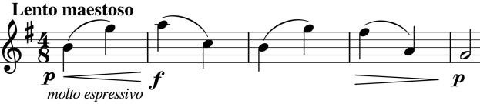

simple theme based on rising and falling intervals of a sixth (*illustrated*). Shortly afterwards the key changes to the major, the

tempo doubles, and the cello plays the theme at its original speed (now in minims) while the violin decorates it with quavers based on falling thirds. The sections repeat in slightly different guises. The next two dumky are broadly similar in structure and follow without a break.

The simple structure of a sequence of dumky frees Dvořák to demonstrate his talent for melody, instrumental colour, and ingeniously effective variation in the way the material is

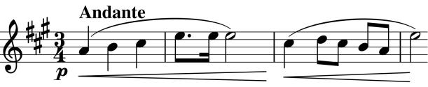

presented. He shows great confidence in handling the form, for instance, near the beginning of the third dumka, the piano plays the simple tune alone just as single notes (*illustrated*), almost nothing, but riveting.

The fourth dumka is at the speed of a slow march; its simple tune is just a rising and then falling scale on the cello – a simplified version of the previous piano illustration. The faster

though not entirely cheerful section is based on the same material, including a slinky little figure that crawls up in semitones.

The fifth dumka is predominantly rapid with the feel of a scherzo interrupted by slower episodes – again the theme is based on an ascending and descending scale. The final dumka, altogether less melancholic, transforms a

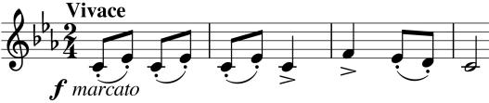

playground taunt (*illustrated)* into the final vigorously stomping dance.