**Programme notes by Chris Darwin. Please use freely for non-profit activities**

**Claude Debussy (1862-1918) "String Quartet No 1 in G minor Op 10" (1893)** *Animé et très décidé*

*Assez vif et bien rytmé*

*Andantino, doucement expressif*

*Très modéré – Très mouvementé et avec passion*

Debussy's own title for this work is rather misleading: he only wrote one string quartet and it was the only work to which he gave an opus number (10 sounds like an impressive number for the ambitious young composer to have arrived at); it was also the only work for which he specified the key. The quartet was written for a music society in Paris who admired the serious, classical Germanic tradition of Haydn, Mozart and Beethoven, in preference to the more frivolous path (operetta, opéra comique) that French music had taken in the 1860s. The piece's form is classical: four conventional movements all derived from its opening motif. Within this structure Debussy weaves his own densely detailed magic using modal along with tonal harmonies. Sadly, neither the society's audience nor Debussy's supporters, such as Ernest Chausson, were impressed; the best thing that anyone managed to say about the quartet was that it was '*bewilderingly full of originality and charm, but diabolically difficult*'. Subsequent generations have still found it full oforiginality and charm, but less bewilderingly difficult; indeed it is now a popular favourite.

Debussy admired César Franck's use of 'cyclical form' where material reappears in later movements. As with today's Haydn quartet, the opening contains the material that returns in various guises in the different movements. For example, it appears, with F# rather than F, in the viola's opening theme of the *Assez vif* second movement. Cyclical form asserts itself

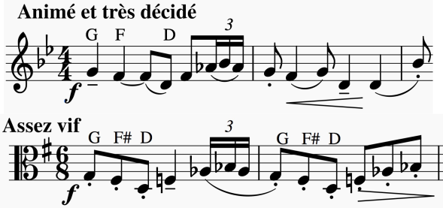

in a big way in the last movement – a movement that gave Debussy problems (*'I think I can finally show you the last movement*

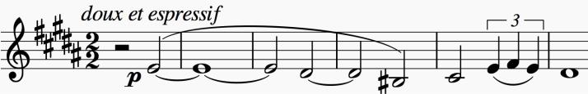

*of the quartet, which has made me really miserable!'*). After about a hundred bars the work's opening theme

returns slowed to half speed and a third lower; it then grows to dominate the movement's native material before the triumphant close.