**Programme notes by Chris Darwin; use freely for non-commercial purposes**

**Max Bruch (1838-1920) String Quintet in E-flat major Op posth (1918)**

*Andante con moto*

*Allegro*

*Andante con moto*

*Andante con moto - Allegro ma non troppo vivace*

By the beginning of 1918, 80-year-old Bruch was not in good health, and neither was Germany - exhausted, finally confronting inevitable defeat and with revolution in the air. So it was perhaps a comfort for Bruch to turn to a project of writing three 2-viola string quintets in characteristically non-revolutionary style with quotes from his earlier work. He had written almost no chamber music since the half a dozen or so works of his youth (aged only 11 he wrote a decent septet), but was inspired by violinist friend Willy Hess, a virtuoso pupil of Joachim. Just two of the quintets survive and the lost third only exists as a reworking by Bruch into an octet. After Bruch's death all three works vanished until 1988 when the parts of the A minor quintet and the octet were discovered in the BBC Music Library, probably left there after a broadcast 'premier' performance in 1937. Today's E-flat quintet only turned up, in a private collection, in 1991 and was eventually published in 2008.

Though written in 1918 the quintets are in the much older *concertante* style, working Hess's first violin hard. Bruch does not exploit the distinctive sound of two violas as Mozart and Brahms had done in their quintets, but uses them substantially to fill out the accompaniment.

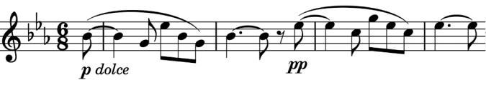

The short first movement (under 3 minutes) of the E-flat quintet serves as a substantial introduction to the second movement. The introduction is dominated by a typically memorable Bruch tune (*illustrated*) whose

tranquil optimism is shattered by the impressive dramatic energy of the *Allegro* second movement.

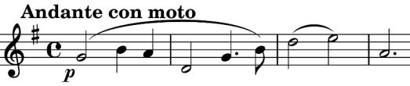

The heart of the work is the beautiful *Andante con moto* third movement with its singing main theme (*illustrated*).

The final movement follows a similar pattern to the first two: a brief *Andante* introduction followed by an energetic *Allegro* . In fact, this introduction has the same theme (*first illustration*) as did the first movement. The final *Allegro* opens with a theme (*illustrated*) which is structurally similar to this introductory one but which is in fact identical to the opening

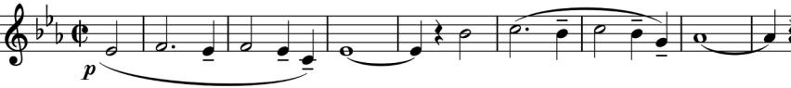

theme of the *Finale* of Bruch's 3rd Symphony. We can excuse the 80-year-old Bruch this nostalgic trip down

memory lane. It serves as a gentler contrast throughout the movement to episodes which are in turn reminiscent of the second movement, giving a pleasing overall structure to a work which it is a real pleasure to have discovered.