**Programme notes by Chris Darwin – use freely for non-commercial purposes Benjamin Britten (1913-1976) String Quartet No.2 in C, Op.36 (1945)**

*Allegro calmo senza rigore*

*Vivace*

*Chacony: Sostenuto – molto più andante – Molto più adagio*

Britten’s compositions for string quartet fall into three groups that were written at very different times of his life: first, a number of early works from his teens (1928-33) reflect his growing independence from his teacher, Brightonian Frank Bridge; second, his first two numbered quartets, the first finished in 1941 in America and the second in October 1945, a few months after the premier of *Peter Grimes*. Finally, his third quartet was composed after the opera *Death in Venice,* shortly before Britten's own death.

Britten had met Bridge through his first violin teacher, Audrey Alston, who had been a fellow student with Bridge at the Royal College. Although Bridge, an established composer, was only teaching violin rather than composition, he was so impressed by Britten's precocious compositions that he befriended him and took him under his compositional wing, probably also encouraging Britten's pacifism. When Britten and Pears left England at the end of April 1939, sailing on the SS Ausonia for Canada, Frank Bridge saw them off, giving Britten his viola. It was their last sight of him, since he died in 1941, the year Britten finished his String Quartet No 1. That work was commissioned by Mrs Elizabeth Sprague Coolidge to whom Britten had been introduced through Bridge.

Today's second quartet was written after Britten's return to England and the success of *Peter Grimes*. In July 1945 Britten and Menuhin spent a gruelling 10 days touringGermany including a visit to Belsen where they played for survivors. Britten said that his visit to Belsen coloured everything he subsequently wrote. The despairing and angry mood of his song cycle *The Holy Sonnets of John Donne* stems from this visit. The second quartet followed shortly afterwards and like the *Sonnets* was written in commemoration of Purcell's 250th birthday that year; it was premiered exactly on Purcell's birthday. The work was commissioned by arts patron and friend Mary Behrend to whom he wrote of it from Aldeburgh: ‘to my mind it is the greatest advance I have yet made’.

The opening bar (*illustrated*) shows Britten's unsurpassed ability to conjure sound: a simple rising tenth with the four strings in octaves and the viola also holding the initial bottom C, the

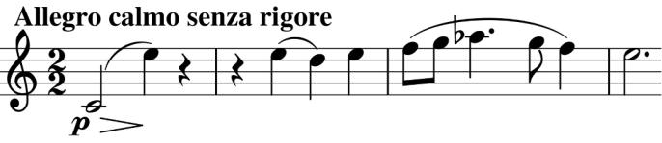

whole on a diminuendo. Simple. And magic. We are entering a different world – part Purcell, part the sea swell of Grimes, part Balinese gamelan - and all grounded in Britten's 'home' key of C. In fact the whole quartet is firmly grounded in C, emphatically so with the 23 consecutive C-major chords at the end of the last movement. It is remarkable that Britten can produce such variety throughout the piece despite keeping so close to this home key.

The second movement's series of nightmare episodes is a complete contrast to the first. It

is in C minor and starts with *fortissimo*

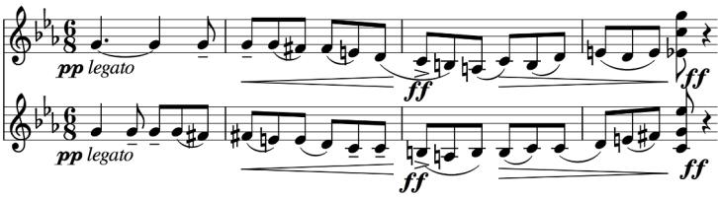

stabs against the muted flutterings of

unsettling moths. The unease is augmented by echoing, parallel descending scales one note apart (*illustrated* ). A ghoulish tripping accompaniment introduces anguished howling octaves from the first violin. Finally the moths flit away into the night and the nightmare is over.

The third movement brings us home from these torments to the security of C major and a Purcellian Chacony. The portentous opening (*illustrated*) heralds a substantial

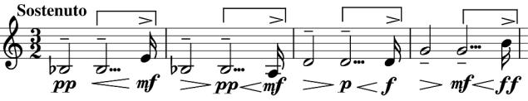

movement, and indeed it is longer than the first two together. The Chacony theme is first played by all four instruments in octaves and is followed by 21 variations in four sets separated by cadenzas from cello, viola and then first violin. As Britten explained in a short program note for the première: 'The sections may be said to review the theme from (a) harmonic, (b) rhythmic, (c) melodic, and (d) formal aspects'. This massive structure ends with a final variation interleaved with those 23 consecutive C major chords: an impressive and original ending to a profound and moving work.