Programme Note by Chris Darwin: please use freely for non-commercial purposes

**Frank Bridge (1879-1941) String Quartet no. 3 (1926)**

*Andante moderato - Allegro moderato*

*Andante con moto*

*Allegro energico*

Brightonian Frank Bridge, born at 7 North St, was the tenth child of a violinist father - bandleader at the Brighton Empire Theatre. The young Frank often played in the band, and his playing earned him a scholarship to the Royal College where he studied violin, and composition with Stanford. He also excelled on viola: while at college he substituted in a Wigmore Hall concert at short notice for the Joachim quartet's viola who had been taken ill, he gave the UK premier of the Debussy quartet, and also performed piano quartets with Fauré. To help earn a living as a student, he composed miniatures, for violinists in particular to perform at home. He became a renowned conductor, substituting for Henry Wood at the Proms, and touring the USA conducting his own music. He taught the young Benjamin Britten composition, maintained his friendship, and touchingly, gave his viola to Britten as he and Pears set sail on the SS Ausonia for Canada in April 1939.

Bridge wrote four string quartets, the first two predominantly tonal and grounded in Edwardian England. But the first world war had a profound effect on him. In a 1947 radio talk, Britten recalled '*the utter horror and revulsion that [Bridge] felt about that catastrophe ... the whole of Bridge's musical world was now shattered – unlimited possibilities, harmonically and texturally especially, became possible*'.

In this new musical world Bridge found his own individual voice emerging from the

influence of Alban Berg and Bela Bartók. On one of his visits to the USA, Bridge's

chamber music had so impressed Elizabeth Sprague Coolidge that in 1920 she awarded

him a lifetime annuity, allowing him more time for composition. She later commissioned

today's Third Quartet which he dedicated to her. Bridge told her that the Third Quartet

'*contains the best of me I do not doubt*'. It is contemporary with Bartók's Third Quartet and

Berg's Lyric Suite.

The violin's opening phrase defies tonality. The first interval [under 1.] is a tritone (or

augmented fourth), a classically

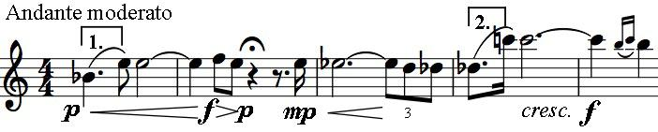

dissonant interval notorious for

evading a settled tonality. After two

bars of semitone moves the violin

leaps an augmented 7th [under 2.]

one semitone short of the octave; after another semitone down to B natural, we have heard all 8 semitones between Bb and F. The accompanying second violin part adds the four from F# and A to complete the full set of 12 within the first five bars.

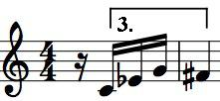

A new world indeed. The augmented 7th returns spikily *energico* on the first violin at the beginning of the *Allegro*, and the tritone [under 3.] soon also reappears around a threatening semiquaver figure, which recurs

throughout the piece. Out of a gentler episode, with three of the strings moving in the same rhythm and in parallel

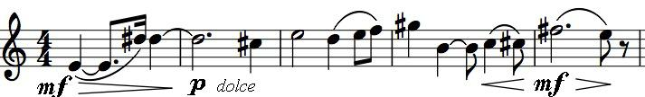

intervals, the viola transforms the angular augmented 7th into a rhapsodic theme. Bridge

develops these and other ideas in a rich and complex movement full of contrasting moods.

The slower second movement inhabits a different world, one that is closer to that of Bartók's 'night music'. In this arch-shaped movement, the initial veiled unease briefly becomes menacing with the dagger-like re-appearance of the threatening semiquaver figure [3.]. The threat retreats, but the unease remains, heightened by the thin hardness of *tremolo* played close to the bridge *(sul ponticello).*

The cello starts the last movement with the notes of the threatening semiquaver figure [3.], but very quietly and stretched in time. The other instruments enter successively, adding the same figure but at a fast tempo, and then again, with shorter intervals between, building tension. The first violin's rising augmented 7th [2.] signals the start of an agitated, angry version of the viola's rhapsodic theme from the first movement. The cello, high on its A-string, gives an anguished cry which is

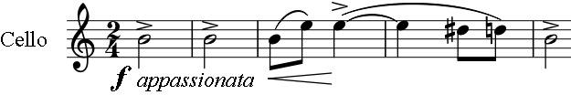

taken up in turn by the others, interspersed with a sinister motif on the viola, like the octave ticks of a fatal clock. These elements

and others from the first two movements are woven together in a masterly and passionate movement. It ends after an intensely agitated climax in uneasy resignation.