Programme Note by Chris Darwin: please use freely for non-commercial purposes

**Frank Bridge (1879-1941) String Quartet No. 2 in G minor (1915)**

*Allegro ben moderato*

*Allegro vivo – Andante con moto – Tempo I*

*Molto adagio – Allegro vivace*

Brightonian Frank Bridge was the tenth child of a violinist father - bandleader at the Brighton Empire Theatre. The young Frank often played in the band, and his playing earned him a scholarship to the Royal College where he studied violin, and composition with Stanford. He also excelled on viola: while at college he substituted at a Wigmore concert at short notice for the Joachim quartet's viola who had been taken ill, he gave the UK premier of the Debussy quartet, and also performed piano quartets with Fauré. To help earn a living as a student, he composed miniatures, for violinists in particular, to perform at home. He became a renowned conductor, substituting for Henry Wood at the Proms, and touring the USA conducting his own music.

His second quartet is dedicated to W.W. Cobbett who in 1905 had endowed a periodic prize which initially was for *'The composition of a short “Phantasy” in the form of a String Quartet'*. 'Phantasy' consciously harks back to a form popular at the time of Purcell. The prize continued for many years and stimulated the composition of English chamber music. In 1905 Bridge came second to WIlliam Hurlstone, another wonderfully talented pupil of Stanford, but won the 1907 prize with a piano trio, and also the 1915 one for 'a quartet in sonata form' with this his second quartet. (Incidentally Britten won the prize in 1932 with a Phantasy Quintet.) Elizabeth Sprague Coolidge was so impressed by Bridge's chamber music that in 1920 she awarded him a lifetime annuity which allowed him to concentrate more on composition.

This G minor quartet begins to move harmonically away from Bridge's earlier Edwardian tonal style; after the First World War, his music is more individual though clearly influenced by the Second Viennese School of Schoenberg, Berg and Webern. Here though, the harmonies, though more adventurous, are still clearly rooted in tonality and the mood is still some way from the darker intensity of his later work. The opening is densely rhapsodic, with complex rhythms competing across the instruments. Then the air clears to a simple triplet accompaniment as the viola is given

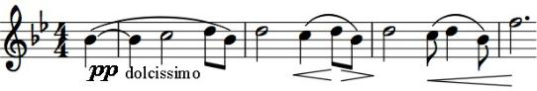

the nostalgic second theme; this 'viola theme' has a family resemblance to a number of other themes in

this and the other two movements, an example of the thematic integration that characterises the piece.

The second movement is a scherzo but with an extended slow middle section instead of the usual Trio. The rapid triplets of the

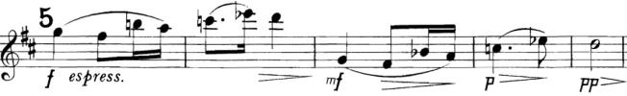

opening lead to a much modified version of the viola theme, first on the cello and then

on the violin (5). The last movement has a slow introduction which is a straight restatement of the viola theme, with yet

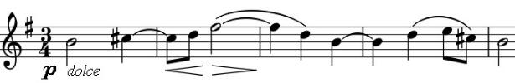

another transformation of it appearing later (illustrated).