**Programme notes by Chris Darwin. Use freely for non-commercial purposes**

**Johannes Brahms (1833-1897) Piano Trio No. 2 in C, Op 87 (1882)**

*Allegro*

*Andante con moto (Tema con variazioni)*

*Scherzo: Presto – Trio: Poco meno presto*

*Finale: Allegro giocoso*

By 1880 Brahms had not composed a piano trio for almost 30 years, but then, like no. 87 buses, two came along at once: one in C, the other in E-flat. Brahms often started to compose contrasting pairs of works at the same time; he started these trios shortly before the contrasting Academic Festival and Tragic Overtures. After composing the first movements of both trios, he set them aside and, ever self-critical, eventually destroyed the one in E-flat - despite Clara Schumann's preference for it. A couple of years later, after finishing his second piano concerto, he returned to and completed this C major trio.

In the 30-odd years since his Op 8 B major trio, the piano had become more powerful, and Brahms had gained experience of writing for piano with a larger group of strings (piano quartets and a quintet) or as

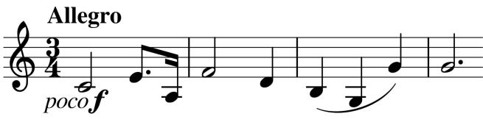

soloist in a piano concerto. Consequently, the relationship between the strings in the Op

87 trio is different from that in the much earlier Op 8 trio. The difference is evident from the

start: the work opens with the violin and cello playing the expansive main theme

(*illustrated*) in octaves treating them as a single voice against the piano. In fact, all the

other movements also open with the strings in octaves. Despite the increased power of

the 1880s piano, and Brahms' proclivity for dense chording, it is important to bear in mind

that the Streicher piano that he was then composing at was considerably lighter in sound

than a modern Steinway concert grand: *"to hear Brahms's music on an instrument like the*

*Streicher is to realize that the thick textures we associate with his work, the sometimes*

*muddy chords in the bass and the occasionally woolly sonorities, come cleaner and*

*clearer on a lighter, straight-strung piano. Those textures, then, are not a fault of Brahms's*

*piano composition."* (Edwin Good).

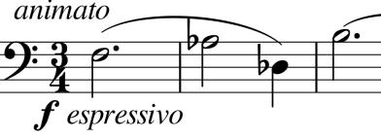

Half-way through the movement Brahms plays a master stroke, the tempo notches up *animato* and the cello transforms the jauntily dotted opening phrase by slowing it in a heartfelt *espressivo* (*illustrated*) above ripples on the piano.

A further modification of the opening gives the theme for the variations of the second movement. The rising third (now A to C) is still there, but the original dotted rhythm is reversed into a 'Scotch snap' (as in '**bo**dy **co**ming through the rye').

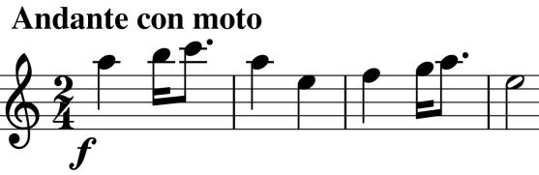

At the end of the theme Brahms pulls a cunning technical trick: the two halves of the last 7 bars (*illustrated*) consist of a phrase followed by its inversion (rising intervals replaced by

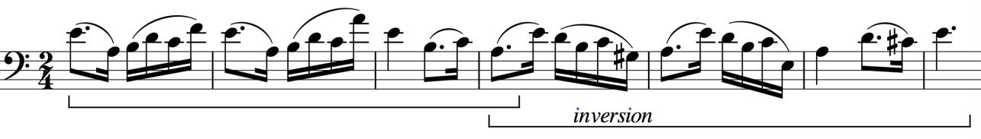

downward and *vice versa*). Such devices reflect Brahms' thorough classical schooling (inversion of fugue subjects was a favourite baroque device), but using inversion to complete a melody looks forward, and perhaps contributed to Schoenberg's famous view of "Brahms the Progressive".

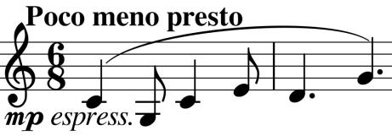

The *Presto Scherzo* again starts with string octaves with the hallmark rising third, but this time in a fleeting pianissimo in C minor. It is gloriously contrasted in the slightly slower trio section by one of Brahms' wonderful soaring melodies (*illustrated*) back in C major.

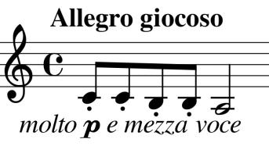

String octaves and a rising third again start off the playful *Finale*

* *Allegro giocoso.* The piano accompanies with a descending figure of repeated quavers (*illustrated*) which is extended and frequently recurs as a sort of laughing motif throughout this good-natured movement.