Programme Note by Chris Darwin: please use freely for non-commercial purposes

**Johannes Brahms (1833-1897) Piano Quintet Op.34 in F minor (1864)** *Allegro non troppo*

*Andante, un poco Adagio*

*Scherzo: Allegro*

*Finale: Poco sostenuto—Allegro non troppo*

Brahms' only piano quintet has an interesting history. The year 1861 was the start of Brahms' 'first maturity' in chamber music; he produced his first string sextet (Op 18) and his first two piano quartets (Op 25 and 26). The next year, following Schubert whom he deeply admired, he wrote a quintet for two violins, viola and two cellos. His close friends, pianist and composer Clara Schumann and violinist Joseph Joachim, were asked for their comments. They were concerned about the choice of instruments. After a private performance, Brahms, discouraged, rewrote the quintet as a sonata for two pianos (rather than the one-piano 4-hand arrangements that he habitually made) and, as with much of his early chamber music, destroyed the original. The 2-piano version was successfully performed in a number of concerts, but Clara and her fellow pianist Hermann Levi suggested alternative scorings to Brahms, who decided on a piano quintet, which he finished in October 1864. The 2-piano version was published 6 years after the piano quintet as Op 34*bis*. There have been a number of creative reconstructions of the destroyed 2-cello original (recently by Anssi Karttunen, the Finnish cellist, and also by Antony Gray, the Australian pianist), but the piano quintet version remains the most frequently performed. As you listen to the work you might like to wonder how it might have sounded with an extra cello and no piano.

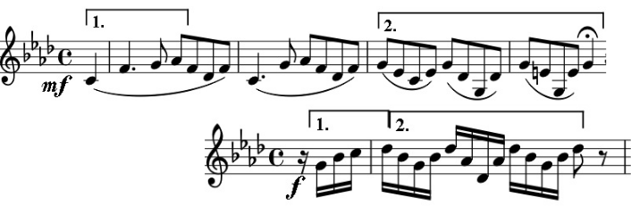

The first movement illustrates Brahms' ability to make simple materials change and grow. Ivor Keys in his BBC Music Guide *Brahms Chamber Music* shows

how the first bars lay out the material with which Brahms will work. The pregnant pause in bar 4 is followed by an

outburst of energetic semiquavers, which take their shape from the notes under [1] and [2], together with a falling semitone assertion by the violins (which will figure prominently in the Scherzo). The semiquavers become the accompaniment and the falling semitone seeds a new theme, which the viola then adopts in a changed form. And so on. In Keys' words “*no extended instrumental composition can ever be convincing if it doesn't possess the coherence that comes from integrity*.”

The slow movement is altogether more straight-forward: generally four bar phrases, simply harmonised forming an ABA structure. The opening mood is gentle, like the *Romanza* of Brahms' later first string quartet. The middle section brightens from A♭ into a bell-like E major and leads back to a more lusciously scored reprise of the first part.

The *Scherzo* is a different beast altogether. The ominous mood set by the *pizzicato* beat on the cello and the threatening dotted rhythm in the strings are abruptly dispelled by a triumphant march. These moods abruptly alternate with the dotted rhythm which is transformed into the manic 'hammer and tongs' passage (illustrated) - we really *do* need the piano for this bit! On its

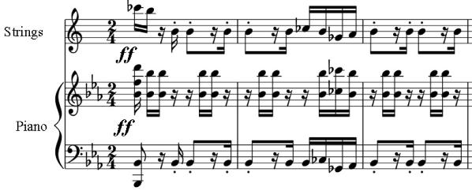

reprise a sinister downward D♭-C semitone is incessantly hammered out. This falling semitone is reminiscent not only of the first movement, but also of the end of Schubert's 2-cello quintet. All this breathless drama is contrasted with the most optimistic of Trios.

The falling semitone at the end of the Scherzo metamorphoses into a rising one in the searching, slow introduction to the Finale. The contrasting episodes of the Finale itself appear to be searching for cohesion, so that when the brakes are at last released on a coda of unusually sustained energy, the audience is swept along to an ending that is designed to bring the house down and them to their feet.