**Program Notes by Chris Darwin. Use freely for non-commercial purposes.**

Johannes Brahms (1833-1897) Piano Quartet No. 2 in A Op. 26 (1861)

*Allegro non troppo*

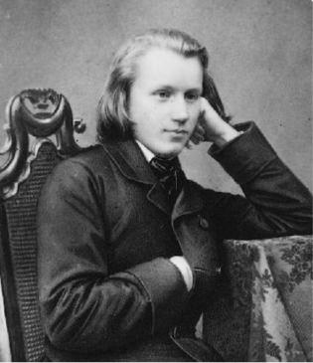

*Poco adagio*

*Scherzo: Poco allegro*

*Finale: Allegro*

In the autumn of 1853 the 20-year-old, well-read, blue-eyed, long fair-haired, slender pianist and composer Johannes Brahms (illustrated) arrived at the home of Robert and Clara Schumann, introduced by the violinist Joachim. As their protégé, Brahms' career flourished, while he in turn not only helped with the household as Robert's illness progressed, but also fell in love with Clara, 14-years his senior

(Brahms' mother was 19 years older than his father). After Robert died in 1856, Brahms and Clara decided to go their separate ways but remained close friends. Brahms then found it hard to compose; he wrote to Clara that he felt he no longer knew *‘at all how one composes, how one creates’*. However, he recovered, partly thanks to Joachim providing him with an encouraging exchange of polyphonic exercises; he also studied early music and folksong and conducted the court choir.

By the early 1860s he was composing a string of chamber masterworks: two string sextets, a piano quintet, two piano quartets, a horn trio and a cello sonata. The choice of forms is a break with the classical masters. Neither Mozart nor Beethoven wrote mature string sextets or piano quintets; as for piano quartets, Mozart wrote just the two that defined the genre and Beethoven wrote three in Bonn in his teens (eventually published as WoOs – works without opus numbers). Closer to home Robert Schumann had written both a piano quartet and a quintet. One reason that Brahms, and Schumann, turned to the larger chamber groups with piano was that pianos had by the 1860s developed the power to stand up to the strength of three or four string instruments. This increased force is certainly exploited by Brahms. His two piano quartets provided a great showcase not only for the piano but also for the strings: their first performances, in Vienna,were given by Brahms with Joseph Hellmesberger's quartet, itself a showcase for the leader Joseph who billed his group as the “*Hellmesberger Quartet, with the assistance of ... [names of the other players]* ”.

Unlike Wagner and Liszt, Brahms respectfully and meticulously adhered to classical forms; however, within those tight structures lies much innovation. Schoenberg wrote a chapter on '*Brahms the progressive*' and Anton Webern believed that Brahms had anticipated the radical developments of their Second Viennese School. Brahms's building on the classical Viennese models would have appealed to his now traditional Viennese audience. While back in 1815, 80% of the works performed at the Viennese *Society of the Friends of Music* were by living composers, by 1849, 80% were by dead composers.

One of Brahms' innovations was what Schoenberg called 'developing variation' – Brahms makes a series of relatively small changes to themes, gradually transforming them into something new. You can hear this in

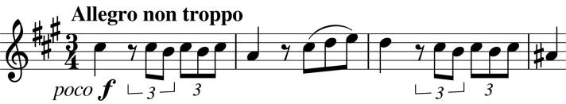

action at the beginning of the first movement as the initial motif is gradually extended and varied. The beautiful, long *Poco Adagio* slow movement is freer in

form - its beautiful melodies paired with original textures of muted strings and piano

arpeggios. The graceful theme of the *Scherzo* is interrupted by the *fortissimo* power of the *Trio* , where the piano and strings compete against each other to see whose octaves are the loudest. This released power continues into the Hungarian-flavoured *Finale* with its even more energetic *animato* ending, designed to, metaphorically at least, bring the house down.