**Programme notes by Chris Darwin. Use freely for non-commercial purposes**

**Johannes Brahms (1833-1897) Horn Trio in E**♭ **Op 40 (1865)**

*Andante*

*Scherzo (Allegro)*

*Adagio mesto*

*Allegro con brio*

For Brahms the early 1860s were a productive time for chamber music: 2 string sextets, 2 piano quartets, a piano quintet and a cello sonata as well as this horn trio. As a child Brahms learned piano, cello and natural horn, so perhaps this work, written shortly after the death of his mother, involved the instruments of his youth (he specified that the horn part could be played by the cello). The quality of the notes produced by hand-stopping a natural horn are significantly different from those of a valve horn, and Brahms exploits these particular qualities in the piece.

The overall structure of the work is unusual for Brahms since it echoes the old Church Sonata (*Sonata di Chiesa*) – a form much used by Corelli, with four movements alternating slow-fast-slow-fast. The first movement

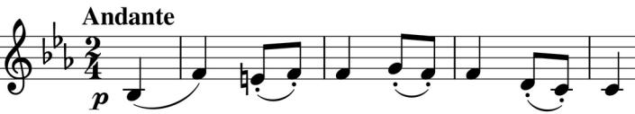

in turn alternates a broad, nostalgically tender *Andante* with a more animated section. The opening theme, though

introduced by the violin (illustrated) is well-suited to the natural horn, which repeats it and later re-introduces it when the *Andante* section returns twice more.

The rhythmically complex Scherzo leads to the emotional heart of the work, the *Adagio mesto*. Dark colours from the piano in the 6 flats of Eb minor, make even more sad atheme of mournful semitones to make a movement of great intensity. But, with the end of the movement, mourning passes and we can move on to the Finale.

Its joyful theme, introduced by the violin (illustrated), along with the subsequent rising fourth hunting call motif again exploit the harmonics of

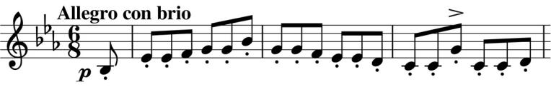

the natural horn and the work ends in blazing sun.