**Johannes Brahms (1833-1897) Clarinet Quintet in B minor, Op.115 (1891)**

*Allegro*

*Adagio*

*Andantino - Presto non assai, ma con sentimento Con moto*

By March 1891 Brahms' creative impetus appeared to have faded away. He had composed nothing for more than a year and had completed his will. But then, visiting Meiningen, the conductor of the court orchestra drew Brahms' attention to the playing of their erstwhile violinist, now principal clarinettist, Richard Mühlfeld (1856-1907), who performed privately for Brahms. As Anton Stadler had previously inspired Mozart, so now Mühlfeld inspired Brahms. There rapidly followed four wonderful chamber pieces: a Trio for piano, clarinet and cello Op 114, today's Quintet Op 115, and two clarinet and piano Sonatas Op 120.

In the hundred years since Mozart wrote his clarinet quintet, the instrument had evolved into something akin to the modern “Boehm” clarinet. Its larger number of keys, and consequently simpler fingering, made rapid chromatic playing easier than was possible on the much simpler clarinets used, albeit to great effect, by Stadler.

The opening B minor theme on the two violins provides much of the basic material for the work.

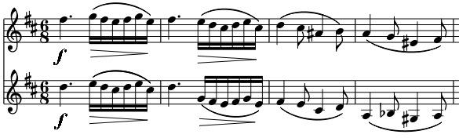

The clarinet then enters with a rising arpeggio just as in Mozart's quintet, and leads us to a contrasting staccato motif with

rapid accompanying triplets that are tossed between the instruments. The *Adagio* in B major has a slow melody in the clarinet accompanied by a Brahms trademark complex rhythm superimposing triplets with

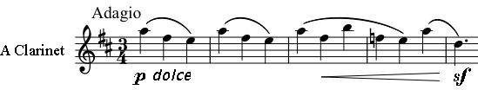

syncopated duplets in the strings. The two illustrated themes are then combined in the turbulent B minor

central section of the movement with gymnastic flourishes from the clarinet. The third movement opens with a calm *Andantino* leading to the *Presto* scherzo and a contrasting Trio section with pizzicato strings. The last movement is a theme and five variations, with the theme related to many of those in the previous movements. The cello leads the first variation, the first violin

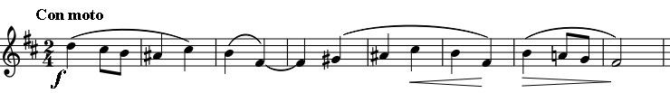

and clarinet the second, the more embellished third and

the fourth, which moves into B major. The viola then returns us to B minor with a restatement of the theme but in the rhythm of the first movement. In the final coda the first violin returns to the very opening of the first movement, the clarinet adds a major version of the viola's restatement and the work ends in peaceful agreement.

Programme notes by Chris Darwin