**Programme notes by Chris Darwin. Use freely for non-commercial purposes.**

**Johannes Brahms (1833-1897) String Quartet No 3 in B flat, Op 67 (1875)**

*Vivace*

*Andante*

*Agitato (Allegretto non troppo)*

*Poco Allegretto con Variazioni*

Compared with his second quartet which the Heath played for us last month, Brahms' third quartet is more genial and relaxed, bucolic even. It was written in the summer of 1875, two years after the first two. Perhaps Brahms' successful publication of these first two quartets had stopped the ghost of Beethoven from looking over his shoulder quite so often, or at least had diverted its attention to Brahms' struggles with his first symphony (which finally appeared the following year as Op 68). Brahms was staying just outside Heidelberg in Ziegelhausen on the river Neckar - 'a very pretty place'. 'I stay sitting here, and write from time to time highly useless pieces in order not to have to look into the stern face of a symphony.' Doubtless, Brahms did not seriously include his third quartet among these 'highly useless pieces'; he preferred it to his first two, and his violinist friend Joseph Joachim thought it among his most beautiful chamber music. After Joachim told Brahms that he had been fingering some passages, Brahms wrote that he wanted Joachim to change the part so that no fingering was necessary: 'The necessity for fingering is proof of bad writing'. Sadly, not all composers are as thoughtful to their performers!

The work is dedicated to a an amateur cellist friend Theodore Engelmann who was professor of physiology at Utrecht. Perversely the work has no cello solo, but unusually favours the viola. Brahms suggested to Engelmann that he might like to change instruments in order to enjoy the viola part in the third movement.

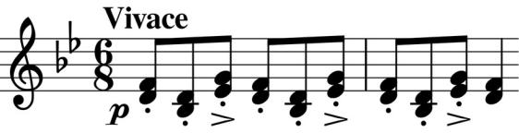

That the viola is going to receive special treatment is evident from the opening bars of the cheerfully playful first movement: the viola in thirds with the second violin plays an off-beat accented flourish

(*illustrated*) very reminiscent of the two-viola opening of Mozart's last string quintet (K. 614). Being Brahms, we soon get a competing phrase which divides the bar's 6 quavers into three groups of two rather than two groups of three. The play between twos and threes continues as the time-signature changes from 6/8 to 2/4 so that 4 quavers now occupy the same time as 6 previously did. But these rhythmic games just serve to enhance the fun.

The second movement has one of those glorious Brahms melodies ( *illustrated*) that you want to just go on: this one gives the first violin 24 bars of bliss and a reprise towards the end.

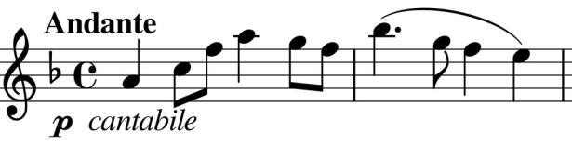

The viola is the star of the third movement. Unhandicapped by the muting of its colleagues, it leads with an agitated theme related to the opening flourish of the first movement. It even gets a mini-cadenza towards the end of the first Minuet-style section.

The last movement is a set of variations on a graceful theme that Brahms might have had in mind when he wrote to Engelmann that 'this quartet resembles your wife somewhat – it is dainty and original!'