**Johannes Brahms (1833-1897) String Quartet Op 51 No 2 in A minor (1873)** *Allegro non troppo*

*Andante moderato*

*Quasi Minuetto, moderato*

*Finale. Allegro non assai*

Brahms’ friend Max Kalbeck claimed that Brahms had destroyed over 20 quartets before the Op 51 pair appeared. That claim is unconfirmed but we do know that Brahms wrote to his publisher in 1869 saying that as Mozart had taken "extreme care" over the six Quartets he dedicated to Haydn, Brahms intended to do the same with his quartets. He had already been working on the two Op 51 quartets for several years, but it was a further four years before they finally appeared, in 1873, after he had arranged a secret performance of them and made yet further revisions. By then, it was eight years since he had published any chamber music.

Brahms’ chamber music spans 40 years of his career (1854-1894), and, for many, is the form that best captures his personality. His first period of chamber music composition included the first version of the B major Piano Trio in 1854, two string Sextets, two Piano Quartets, a Piano Quintet (initially composed as a now lost 2-cello string quintet) and the Trio for french horn, violin and piano (1865). So he was no stranger to chamber music, but composing for the string quartet raises particular problems, both technical and, especially for the classicist Brahms, historical. The quartet is a sparse medium, sparser than the string sextet and the piano trio, quartets and quintet that he had already written. Here above all Brahms found that *“It is not hard to compose, but what is fabulously hard is to leave the superfluous notes under the table.”* Brahms’ floor must have been littered withnotes, for in these quartets he achieves a new formal compactness and great economy of thematic material within a sound world that is uniquely his own.

Although this A minor quartet is dedicated to Brahms' surgeon friend Theodor Billroth, it is possible that it was originally intended for another good friend, the violinist Joseph Joachim. Kalbeck points out that the opening

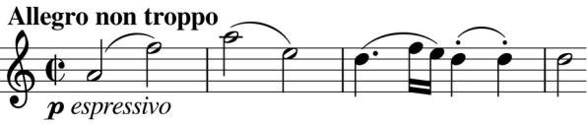

minims of the second quartet (illustrated) use the notes FAE, the abbreviation of Joseph Joachim's motto 'Frei, aber einsam' (Free, but

lonely). That Joachim is not the dedicatee could be because of a recent falling out between him and Brahms over Joachim's failure to programme a performance of Brahms' German Requiem. The more animated second subject, like the opening carries a hallmark of Brahms: the opposition of duple against trips

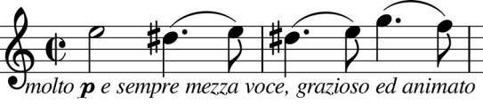

time. The tune (illustrated) and the crotchets of the cello's pizzicato are in duple time, while the viola plays a triplet figure similar to its

accompaniment to the original FAE theme. This second theme underlies the opening of the second movement (illustrated). Its

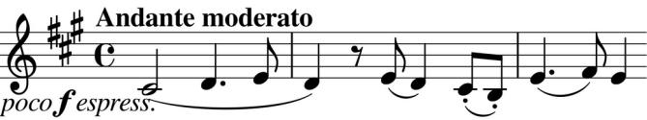

calmness is augmented by the accompaniment now agreeing on duple rather than contrasting in restless triple time.

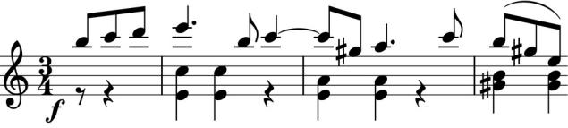

After a novel 'Quasi Minuetto' whose conventional triple time is interrupted twice by trio-like section in scampering duplet

semiquavers, we are plunged into the fiercely energetic Finale. Now the three against two

face-off is full frontal. The lower parts pointedly mark the triple time of the time-signature, while the first violin insists on a theme which falls naturally in two beats (illustrated).