**Programme notes by Chris Darwin. Use freely for non-commercial activites.**

**Alexander Borodin (1833-1887) Scherzo in D major from 'Les Vendredis'**

The illegitimate son of Georgian nobleman Luka Gedevanishvili, Alexander Borodin was given the surname of one of his father's serfs. He trained as a chemist and a surgeon in the St Petersburg Medical-Surgical Academy and pursued a distinguished career both as a chemist and as an educator – initiating medical courses for women. As a sideline, he learned the piano and the cello and studied composition under Balakirev. The two of them, along with Rimsky-Korsakov, Moussorgsky and Cui formed 'The Five' – composers of the New Russian School. Borodin was the only one to be seriously attracted to chamber music, which he had grown to love (particularly Mendelssohn) while studying chemistry in Heidelberg in his late twenties.

The 'Fridays' of today's *Scherzo* were musical parties given in St Petersburg at the home of Mitrofan Petrovich Belaieff. A wealthy lumber merchant, in 1885 he founded a publishing house in Leipzig to secure international copyright for the Russian composers of whom he was an energetic and generous patron. At his Friday soirées, an amateur string quartet led by Belaieff performed a mixture of classical and romantic works ending with something by a contemporary Russian composer. The present *Scherzo* is from a collection published by Belaieff's firm in 1903 after his death. It consists of 16 separate string quartet movements by various composers that had previously been performed at the Friday gatherings.

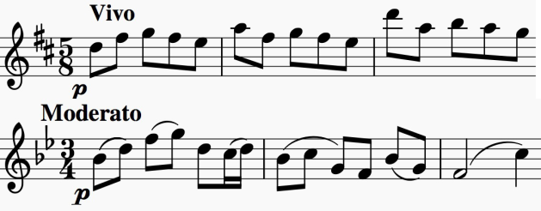

Borodin's *Scherzo* rockets along in the tricky time-signature of (2+3)/8, sandwiching a slower and more conventionally metred *Moderato Trio* section. It is an entertainingpiece, for which the Friday-nighters would have been grateful. Those of us who take a daily dose of statins have another reason to

be grateful to Borodin. He was the co-discoverer of the 'Aldol reaction' which is now used to join two smaller organic molecules in the commercial production of Atorvastatin, the best selling drug of all time. Now there's a polymath!