**Programme notes by Chris Darwin. Please use freely for non-commercial purposes**

**Alexander Borodin (1833-1887) String Quartet No 2 in D (1881)**

*Allegro moderato*

*Scherzo: Allegro*

*Notturno: Andante*

*Finale: Andante — Vivace*

The illegitimate son of Georgian nobleman Prince Luka Gedevanishvili, Alexander Borodin was legally born a serf and, as was customary, was given the surname of one of his father's serfs. However, his father was generous to both him and his mother and he was raised in comfort in the prince's apartment in St Petersburg. His father arranged for his mother to marry a wealthy, elderly physician and freed Alexander from serfdom.

Alexander trained as a chemist and a surgeon in the St Petersburg Medical-Surgical Academy and pursued an extremely distinguished career both as a chemist and as an educator. As a sideline, he learned the piano, flute, violin and cello and studied composition under Balakirev. The two of them, along with Rimsky-Korsakov, Moussorgsky and Cui formed 'The Mighty Handful' or 'The Five' composers of the New Russian School. Borodin was the only one to be seriously attracted to chamber music, which he had grown to love (particularly Mendelssohn's) while studying chemistry in Heidelberg in his late twenties.

Heidelberg also features in Borodin's Second Quartet. It is thought to be a 20th anniversary present to his wife, the pianist Ekaterina Protopova, as an affectionate evocation of their first months together in Heidelberg. Ekaterina fought for women's rights, converting her husband to the cause. Indeed the project of which Borodin was most proud was the revolutionary St.Petersburg Medical School for Women. Administering the School occupied so much of his time that not even this immensely talented 'Sunday composer' managed to write anything substantial in the years following the Second Quartet.

The quartet shows Borodin's wonderful lyrical gifts. The cello opens (illustrated) with a warmly affectionate theme whose tender triplet invites the violin to take over. Indeed much of the quartet is a happy combination of cello and violin, not least the famous *Notturno*. The cello (illustrated) sings its rapturous melody twice before handing over to the violin

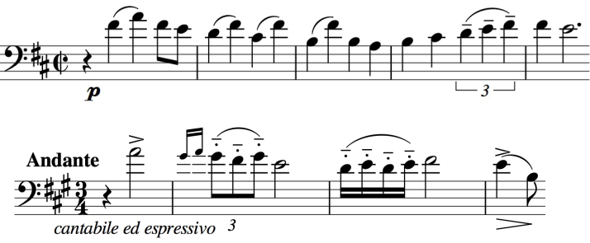

who also sings it twice before the pace quickens. Lucky the wife to have such an anniversary present. The *Notturno's* tune is the star of Robert Wright and George Forrest's musical *Kismet.* It wins against strong competition since all the numbers in *Kismet* are based on Borodin: the second movement of this quartet provides '*Baubles, Bangles and Beads'* and *Prince Igor* much of the rest.

Those of us who take a daily dose of statins have other reasons to be grateful to Borodin. Not only did he anticipate the link between cholesterol and heart disease, but he was the co-discoverer of the 'Aldol reaction'. This reaction is used to join two smaller organic molecules in the commercial production of Atorvastatin, the best selling drug of all time. Now there's a polymath!