**Programme notes by Chris Darwin. Please use freely for non-commercial purposes.**

**Ludwig van Beethoven (1770-1827) Piano Trio in D, Op.70 No.1 (Ghost) (1808)**

*Allegro vivace e con brio*

*Largo assai ed espressivo*

*Presto*

1808 saw Beethoven composing at full power: his Fifth and Sixth Symphonies, the Choral Fantasia, the A major cello sonata as well as the two Op 70 piano trios all come from this year. The cello sonata and the piano trios seem to have been part of a conscious decision by him to revisit the chamber music forms with which he had made such an impact shortly after his arrival in Vienna.

Why the '*Ghost'* trio? The name was coined by Carl Czerny, pianist, composer, pupil and friend of Beethoven who wrote that the slow movement always reminded him of the appearance of Banquo's ghost in *Macbeth*. It is not known whether Czerny was aware that Beethoven had included in the sketchbook that he had used for the *Ghost* Trio preliminary ideas for an opera based on *Macbeth*. Whether or not Beethoven specifically had Banquo in mind, the trio is certainly dramatic.

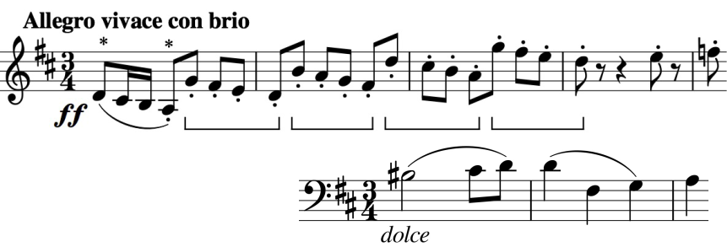

The opening (illustrated) is ferociously violent with groups of four quavers (bracketed) battling with the triple-time key signature. Immediately,

though, the cello presents an 'aching, tender melody' (illustrated); each of its first two bars presents a motif for later development as the movement batters us with conflicting emotions.

The eponymous slow movement is marked *Adagio assai* – Very slow – and slow it is, I know of none slower in chamber music. In many performances, each crotchet beat takes almost 4 seconds. A consequence of this sepulchral tempo is that in order to get the players to play fast you have to write lots of notes in the bar: just before the end there are shuddering bars that contain 48 separate triplet hemi-demi-semi-quavers ! As Angus Watson points out, these trembling figures are reminiscent of Florestan's despairing aria at the opening of Act 2 of *Fidelio*, and this movement

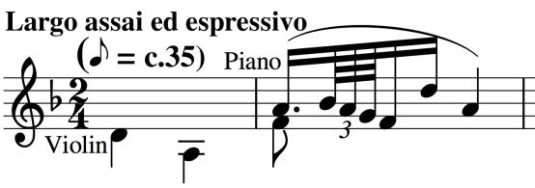

lacks none of its spine-chilling passion. Note that the opening two crotchets (illustrated) D and G are the same notes as the first two crotchet beats in the opening theme of the first movement (*).

The last movement opens expansively and genially, then pauses twice for breath, gathering its strength to lay some of the preceding ghosts.